Quizzes – Importing Quiz Questions Using Respondus

- Under the “Start” tab, change (if not already) “Current Personality” to Desire2Learn.
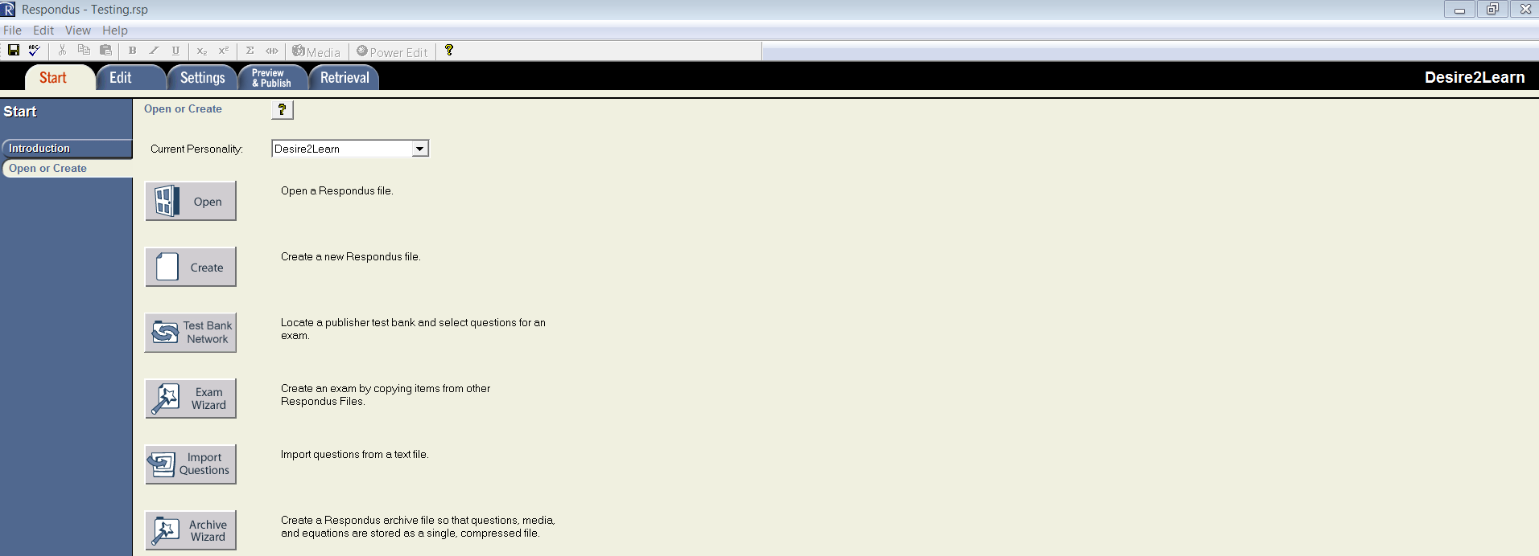

- Click “Open”.

- Choose the quiz from your list. If you are not seeing it, click “Browse” to find the file on your computer.
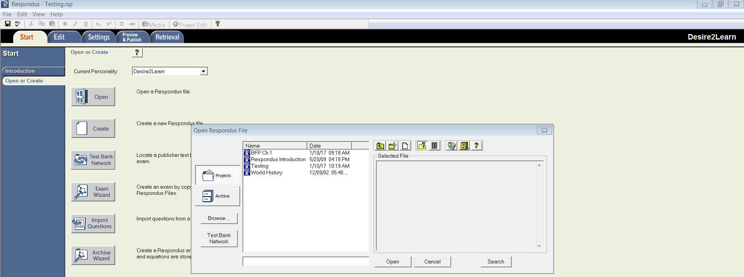

- Click “Open”

- Your questions will populate.
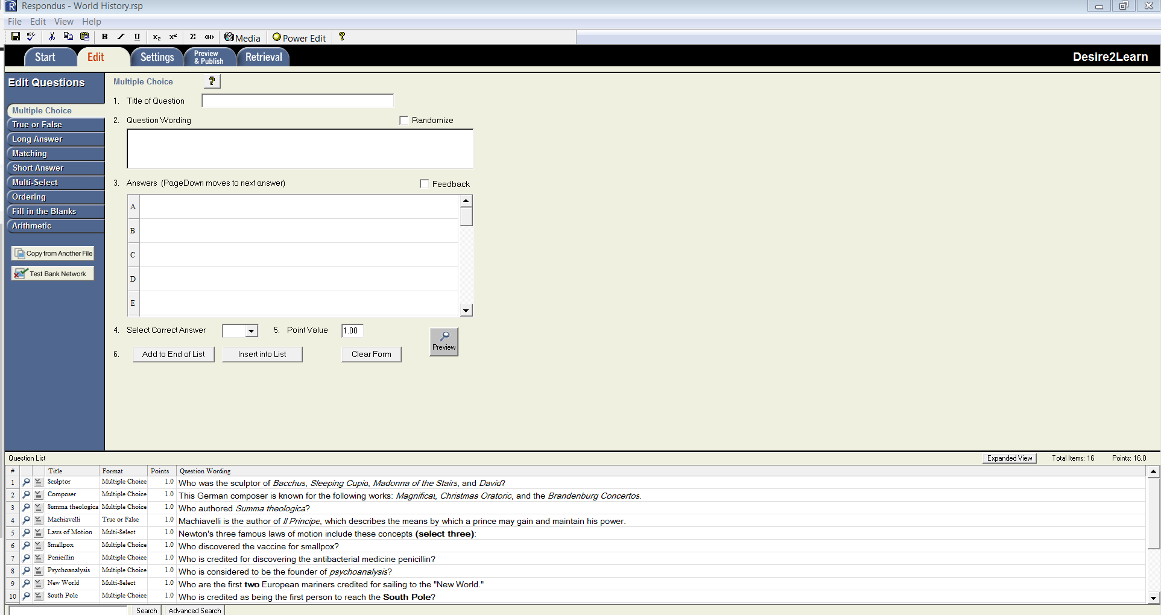
- Click “Preview & Publish”.

- Make sure “Publish” is selected, then click “Publish Wizard”.
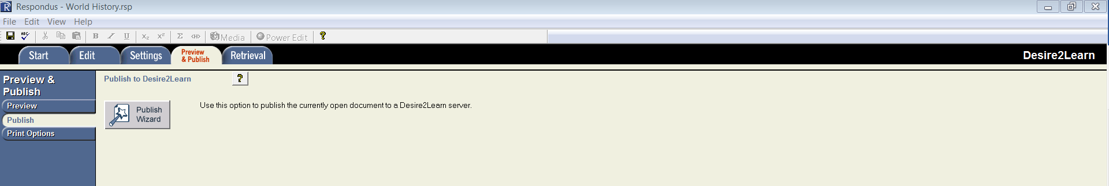

- A pop up appears. Highlight the radio button “Export QTIXML for manual upload to Desire2Learn”.
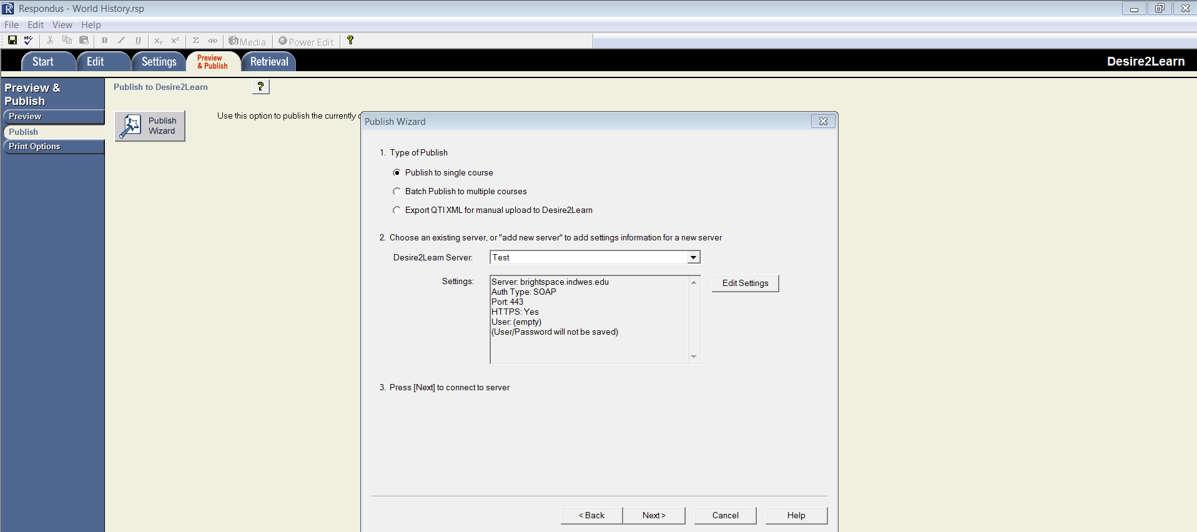
- Click “Next”.
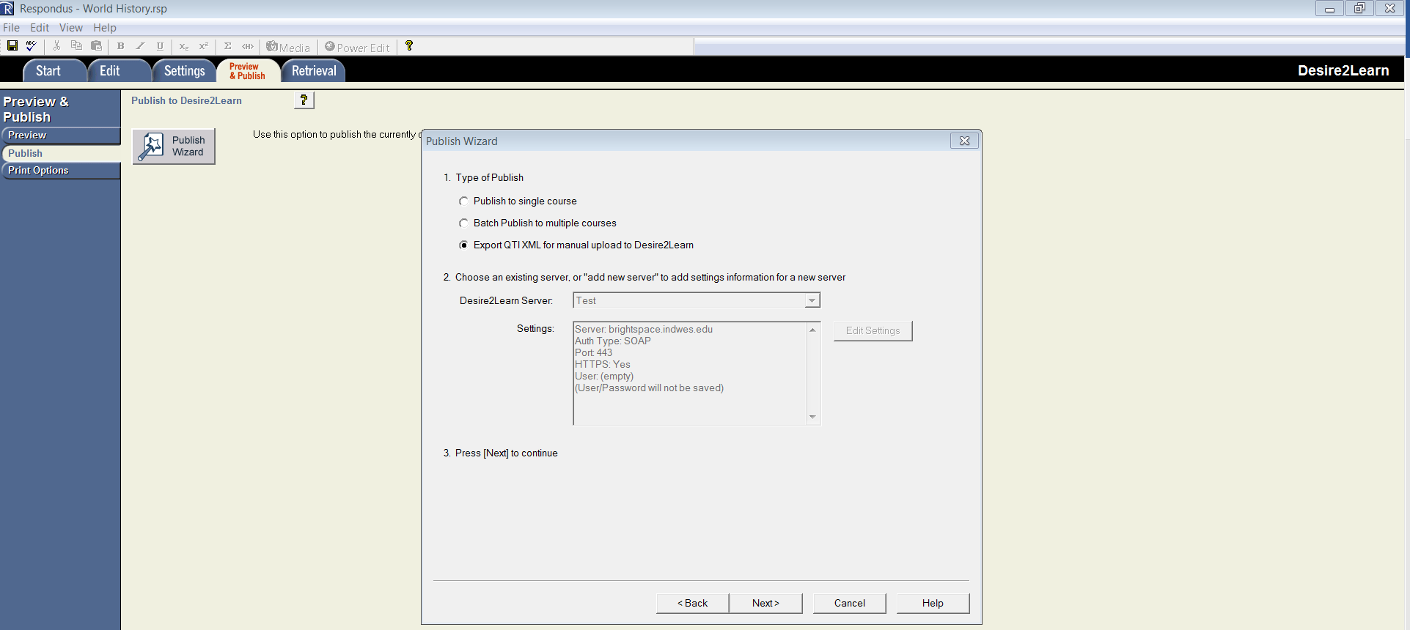

- You now have three options for #1.
- Choose “Quiz” if you would like the system to create a quiz. You can push it to the Question Library later if you would like.
- Choose “Self-Assessment” if you would the system to create a self-assessment.
- Choose “Question Library Section” if you would like the questions to be placed in the Question Library for later use.
In my example, I will be placing my questions in the question library for later use.
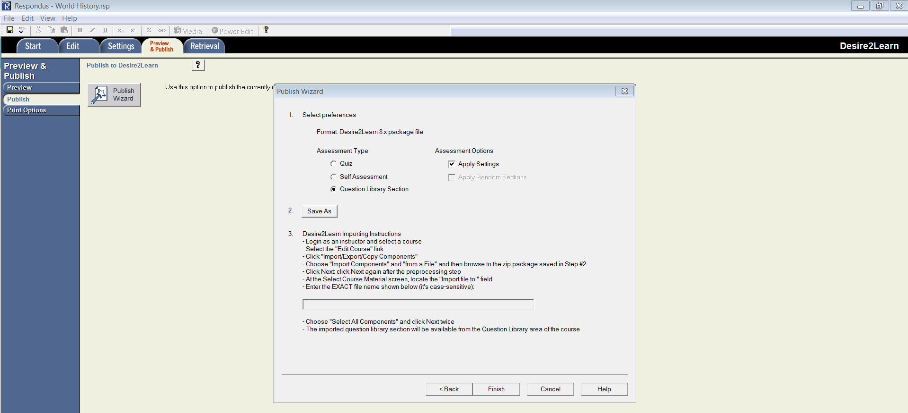

- Click “Save As”. That is #2 and your computer pop up will appear. Type a file name and click “Save”.
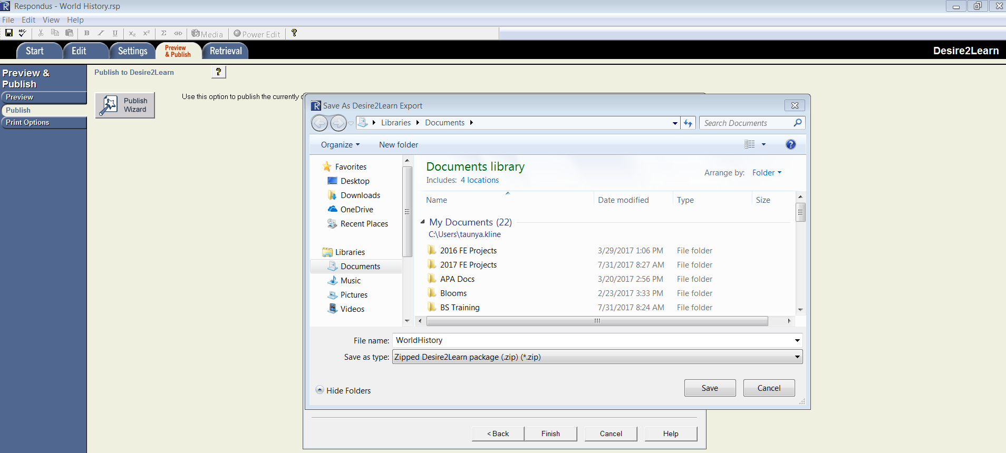

- Go to your files on your computer and located the file on your computer that you just saved. NOTE: This will be a zip file not an individual document.
- Once you have the file, double click the file and you will go back to the Respondus page. You will know it is correct when you see the title of the file in the box for #3. The title of the file I saved was “Test2” and now “Test2” has appeared in the box.
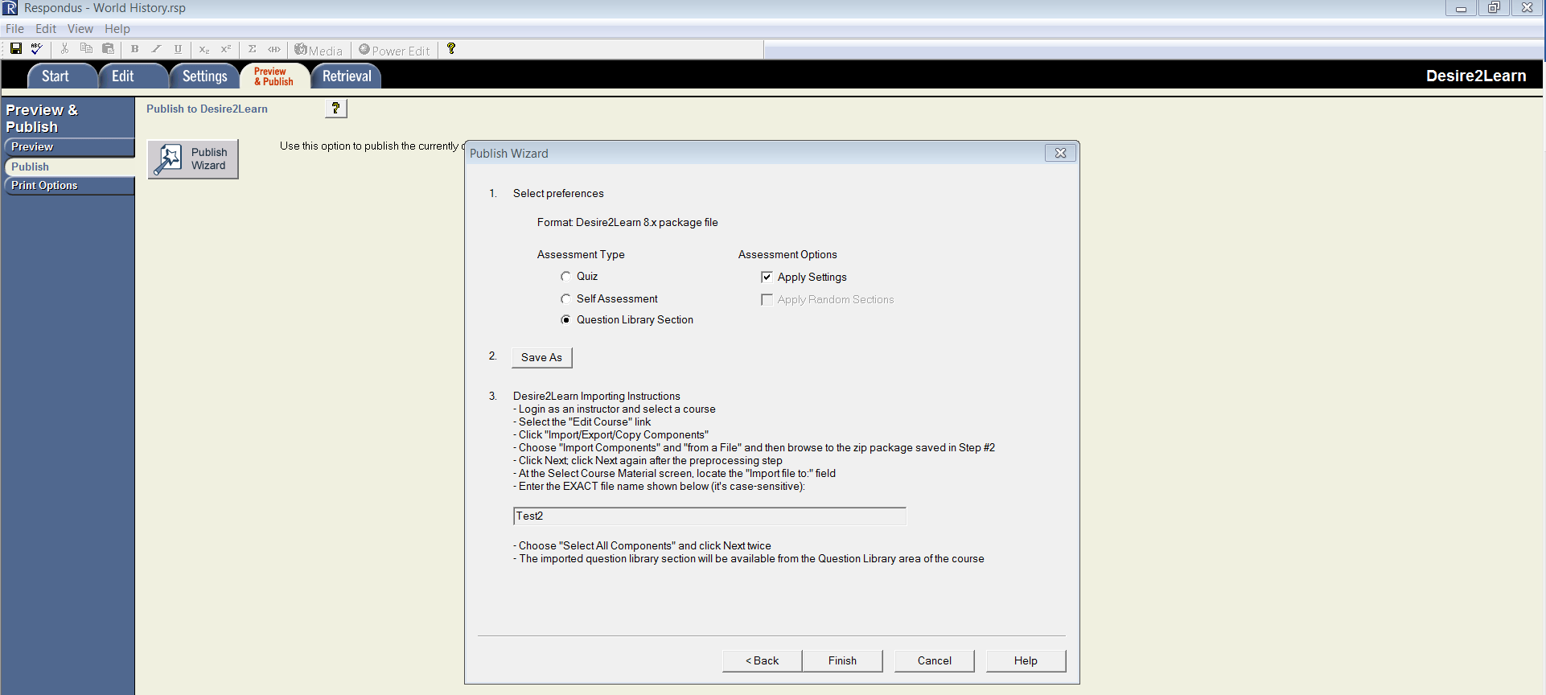

- Click “Finish”.

- Go back to your course.
- Click on the Cog on the Minibar.
- Click “Import/Export/Copy Components”
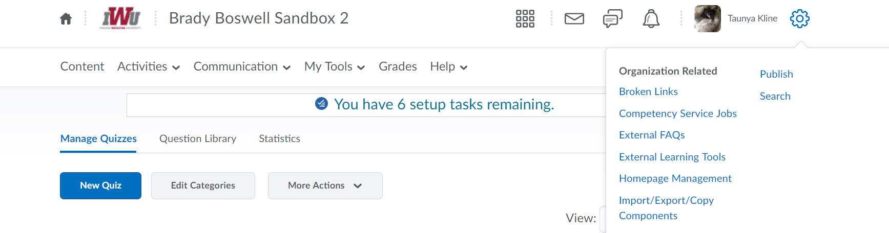

- Scroll down and click “Import Components”.
- Click “Start”.
- A pop up will appear and click “Upload” and find your zip file from your computer.

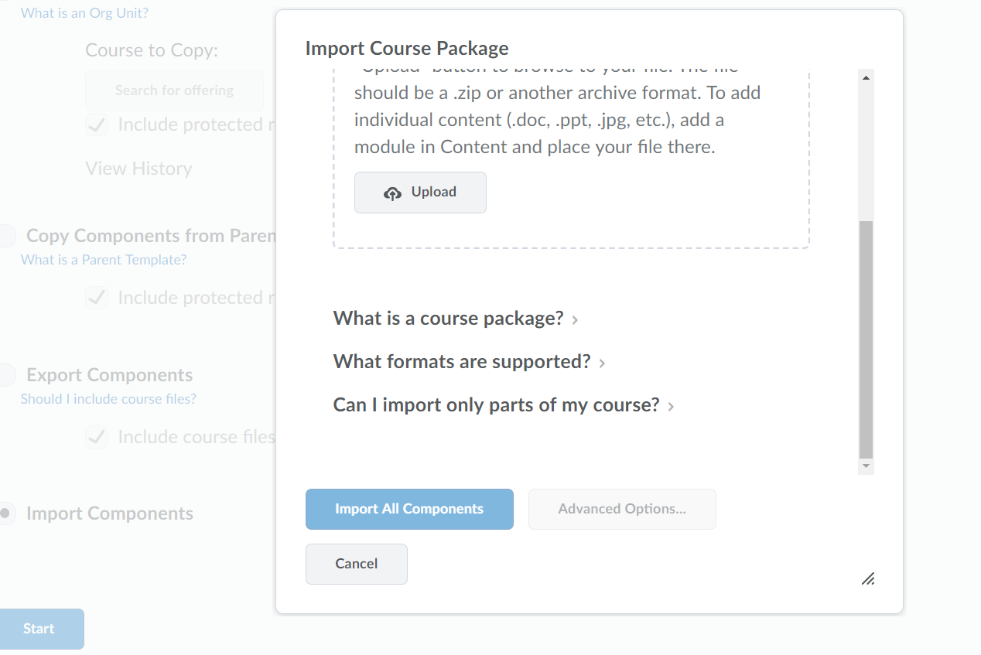

- Click “Open” once you find the file.
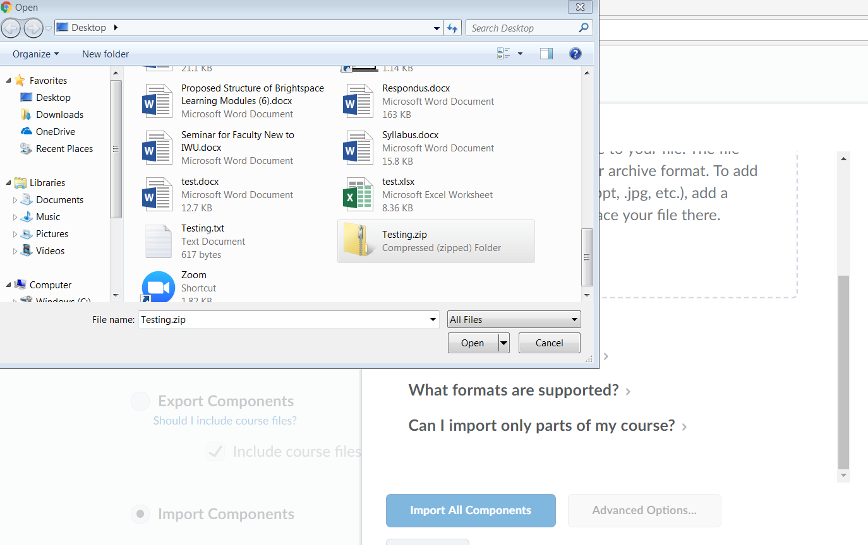

- Click “Import All Components”.
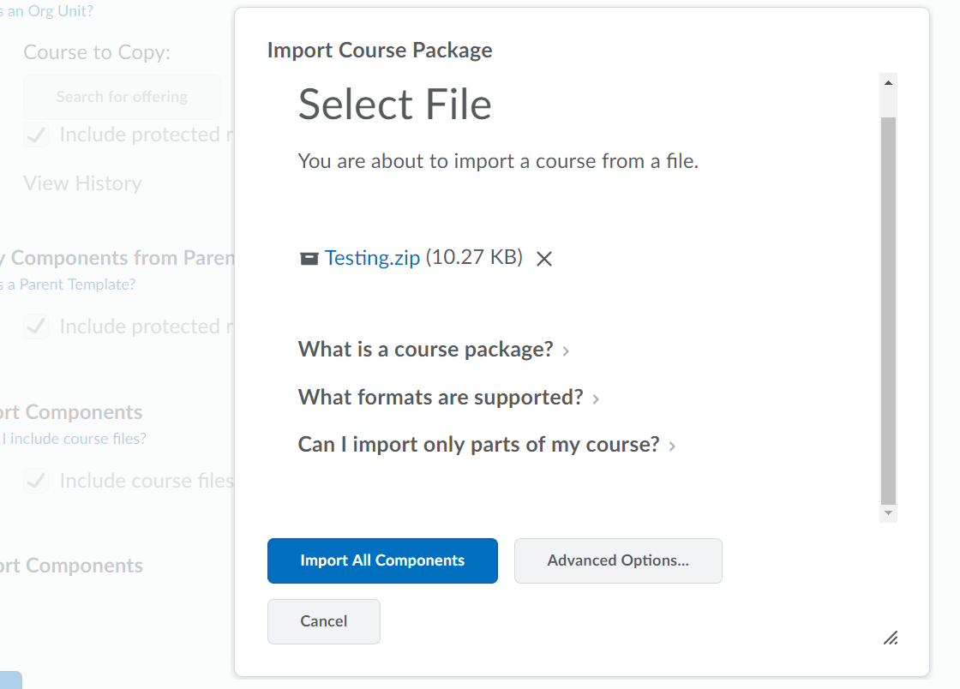

- You will get a successful message. If it says it was unsuccessful, try uploading the file again.
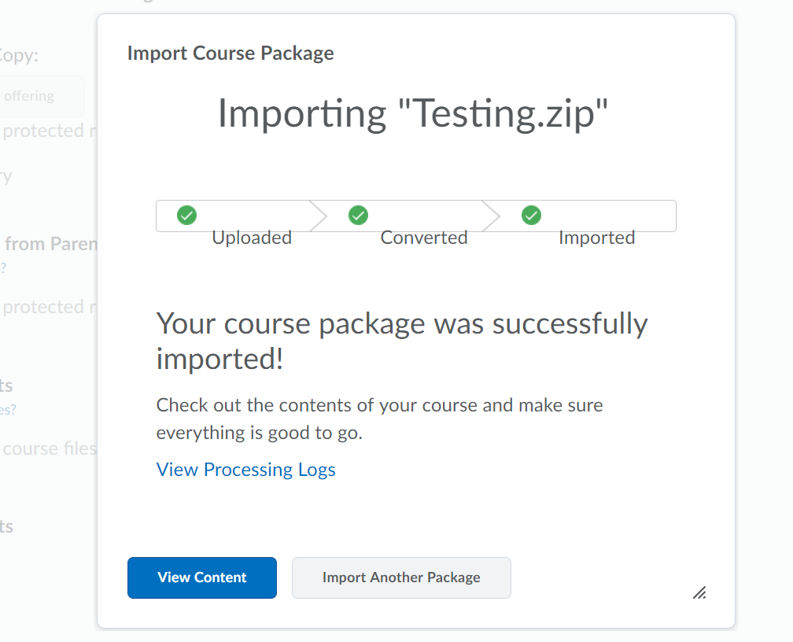

- Go to your quiz list and you will see it at the bottom of the page.
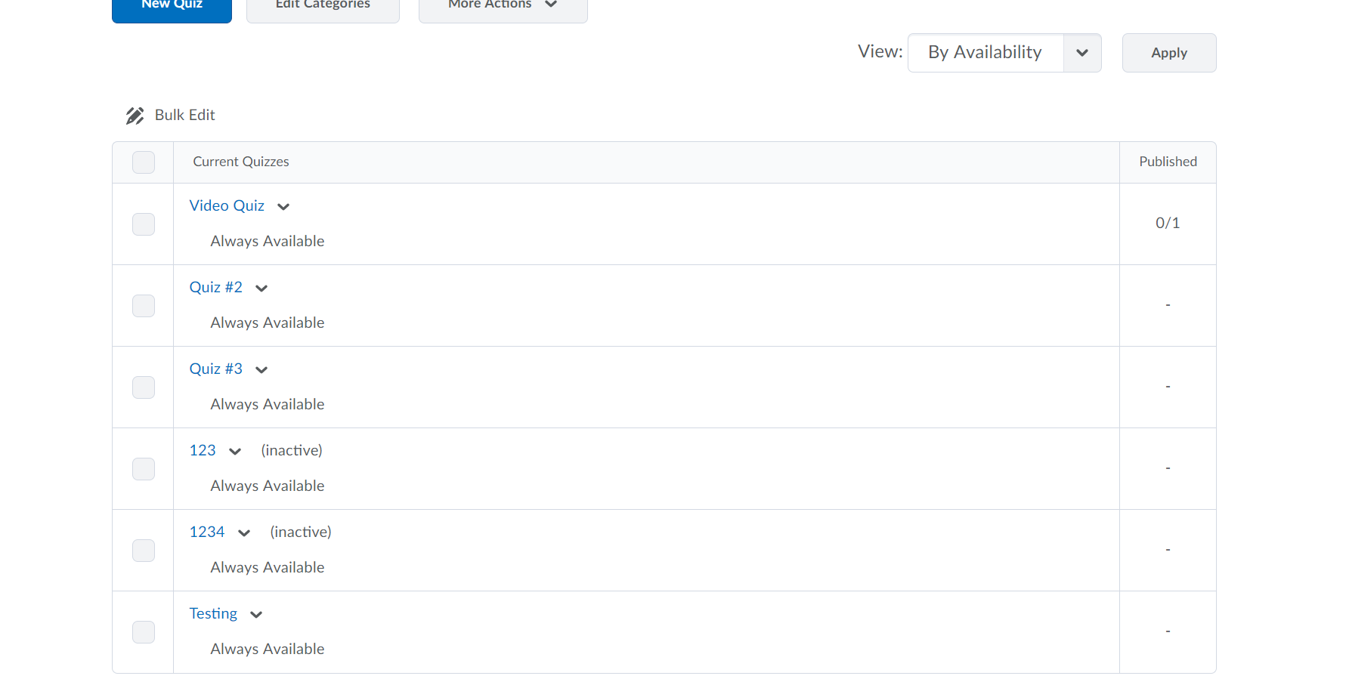

- You are done! Proceed to #26 if you want to place the questions in the Question Library for future use.
- Click on the title of the quiz. The title is in blue.
- Scroll down and click “Add/Edit” Questions”
- Now you are looking at the questions.
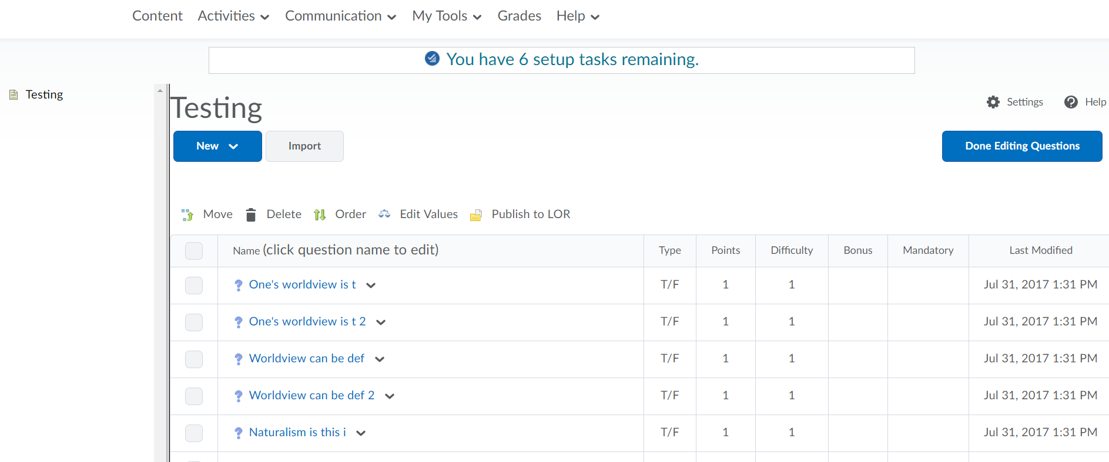
- Click “Done Editing Questions”

- Go to the Question Library and click “Import”.
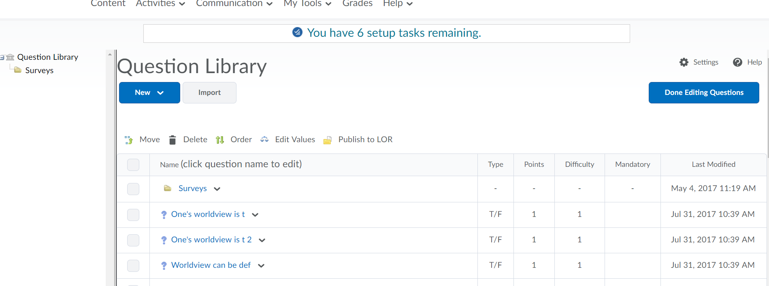

31.
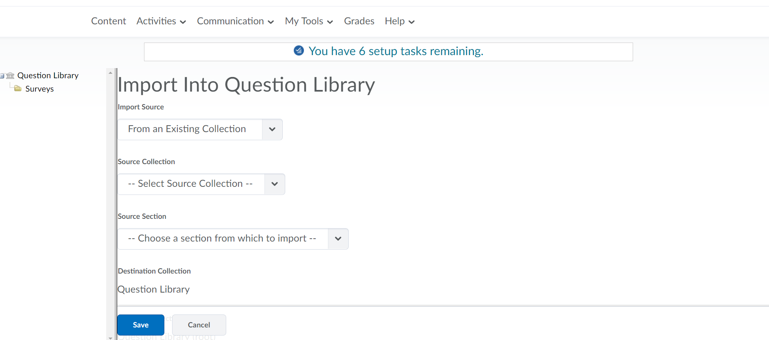
Most of the time you will choose “Collection Root”
Choose the name of the file.
Make sure you choose “From an Existing Collection”
- Scroll through and choose your questions you want to add. If you want to add them all click the box next to “Collection Root”.
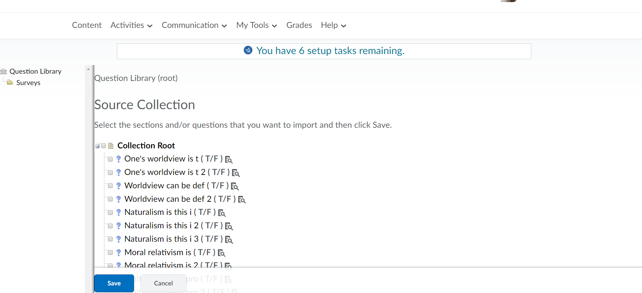

- Click “Save” and you are done.

