Giving a Student Special Access

- Navigate to the dropbox using the Activities dropdown menu.
- Select Quizzes.

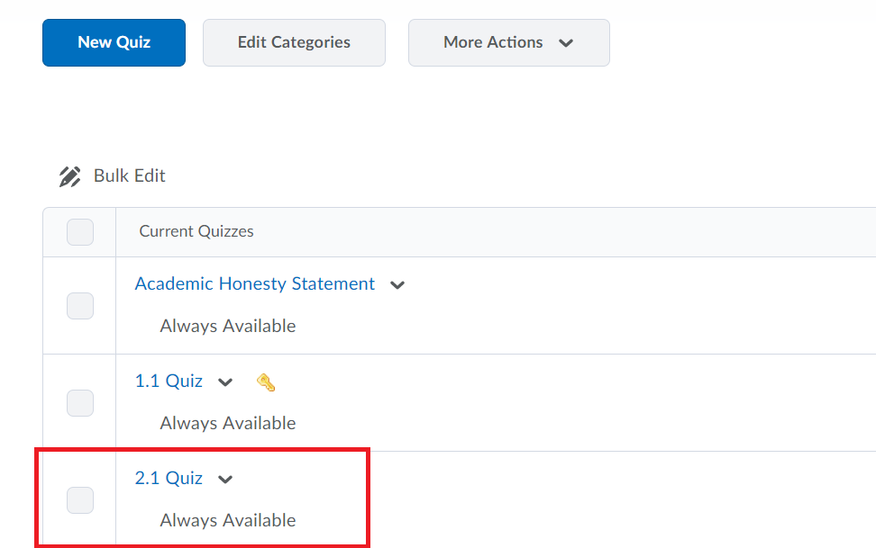

- Locate the quiz you need to modify.

- Click the arrow next to the quiz title and select Edit.

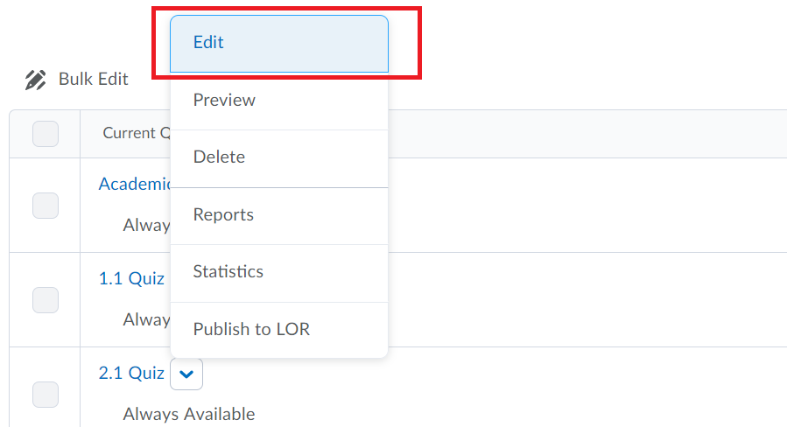
- The quiz will open by default to Properties.
- Select the Restrictions tab.

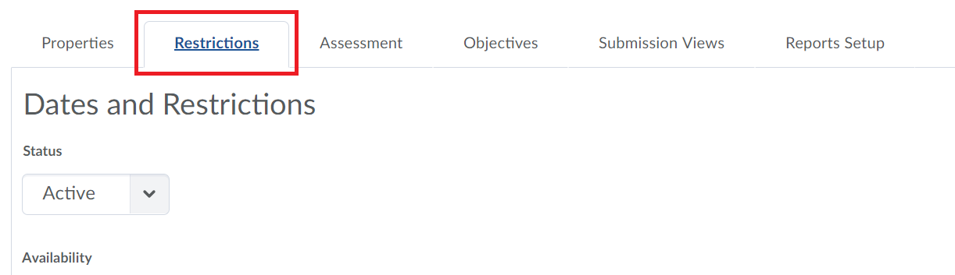

- Scroll to the bottom of the page to locate the Special Access options.

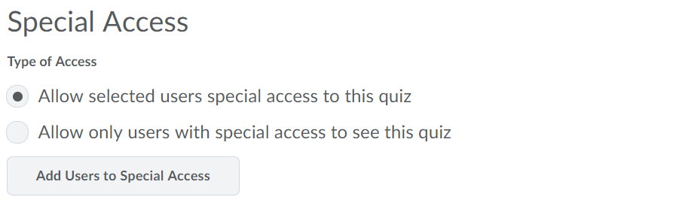

- There are 2 radio buttons.
  - The first will allow specific students access to the quiz and allow them to have different restrictions. All other students will still be able to access the quiz with the standard restrictions.
  - The second will allow ONLY students with special restrictions to access the quiz.
- Click the Add Users to Special Access button.

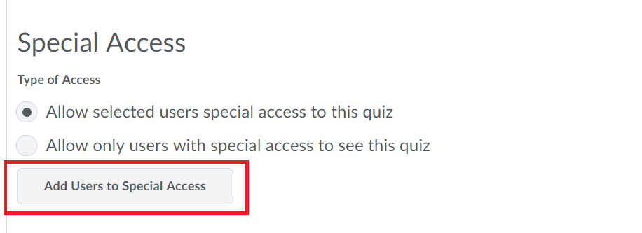
- Changing anything in this screen will modify it for any students with special access.

Availability
- You can adjust when a student has access to the quiz.
  - By clicking the boxes by Has Start Date and Has End Date, you can adjust the time and date the students with special access have access to the quiz.

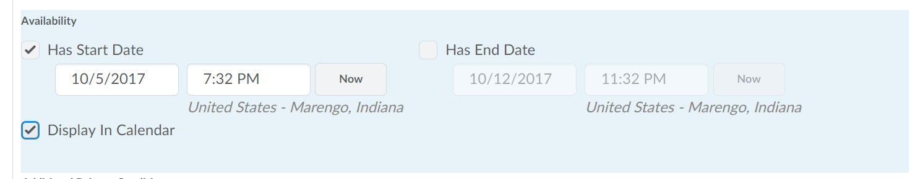

Timing

- There are 3 radio buttons to change the time limit allowed for special students.

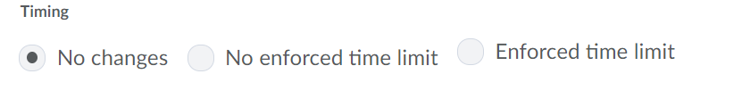

- The first (No Changes) will leave the time limit unchanged from the quiz’s existing properties.
- The second (No Enforced Time Limit) will allow students with special access to receive no penalties for exceeding the time limit.
  - The time limit can be changed by changing the number of minutes allowed in the box.

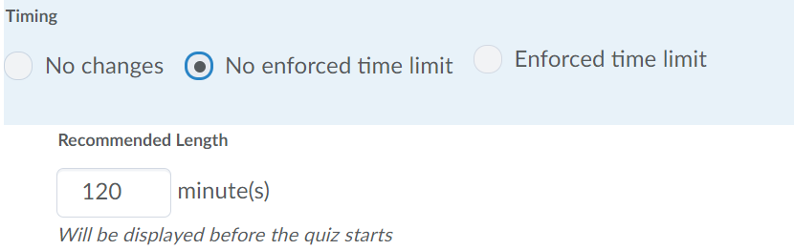
- The third (Enforced Time Limit) will allow students to have a modified time limit to complete the quiz.

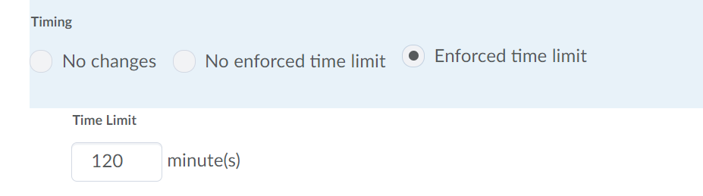

  - The time limit can be changed by changing the number of minutes allowed in the box.
  - To assign an alternate grace period, click the box next to Assign Alternative Grace Period and change the grace period in the box

  - To assign alternate late behavior, click the box next to Assign Alternative Late Behavior and select the late behavior needed for the student by clicking the appropriate radio button.

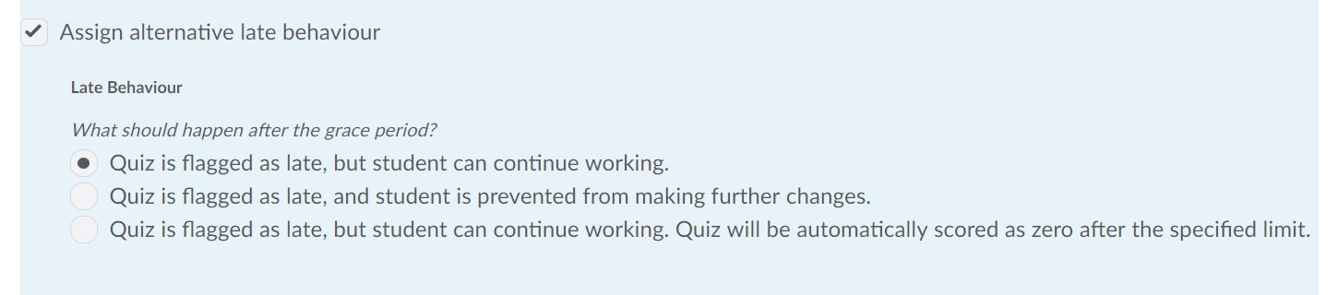

Attempts
- The number of attempts allowed by the student can be modified.
  - To change the number of attempts, click the box next to Override Attempts Allowed.

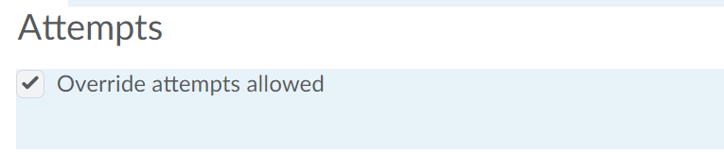
  - Use the drop-down box to adjust the number of attempts allowed.

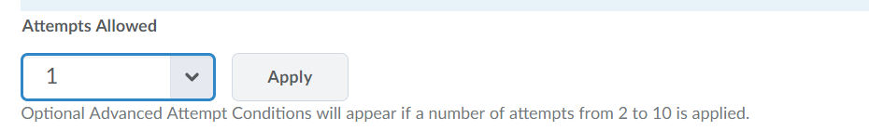
  - Click the Apply when done.

Users
- This section will allow you to search for and select students to have special access.

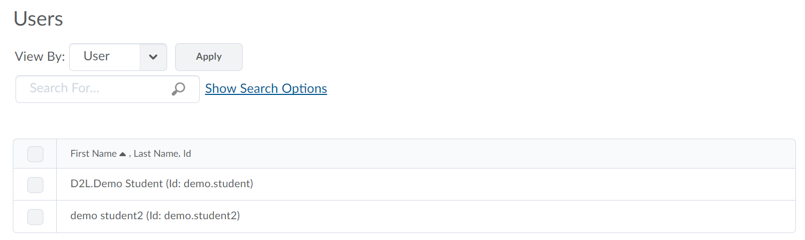
- Using the drop-down menu will allow you to view students by either name or group.

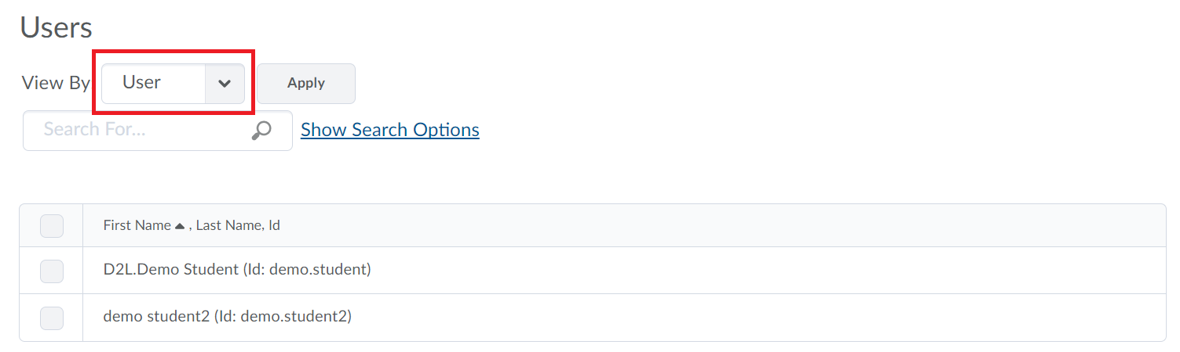

  - Once selected, click Apply.
- You can also use the search field to search for specific students.
  - Selecting Show Search Options will allow you to modify the search criteria used.

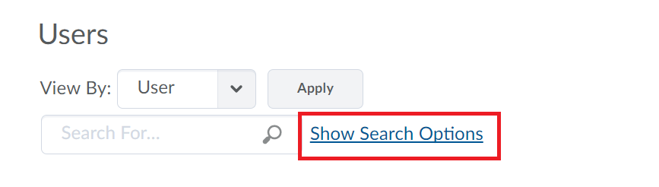

  - Check the boxes allow search to look for that criteria.

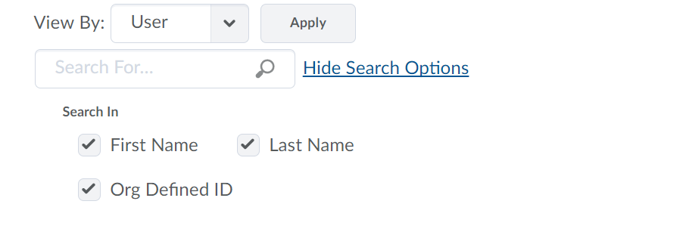
  - Uncheck the boxes to disallow search to look for that criteria.

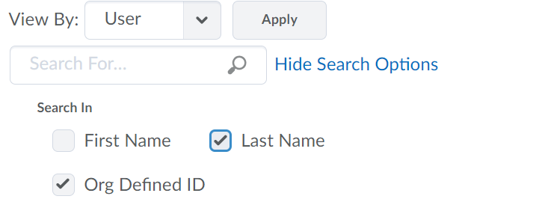

- Select the students that need special access by clicking the boxes next to their names.

- When completed, click Add Special Access.

- All students with special access will be displayed in the Special Access section at the bottom of the Restrictions tab for the quiz.

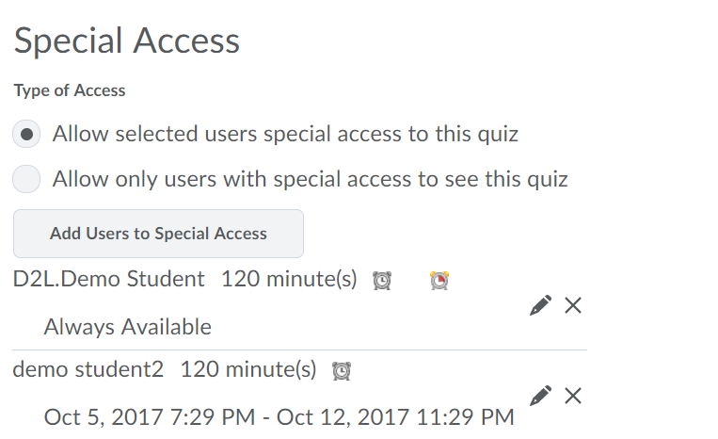

Multiple Users
- If multiple students require different levels of special access, click on the pencil icon by their name and complete steps 10-15 in this guide to modify their special access.

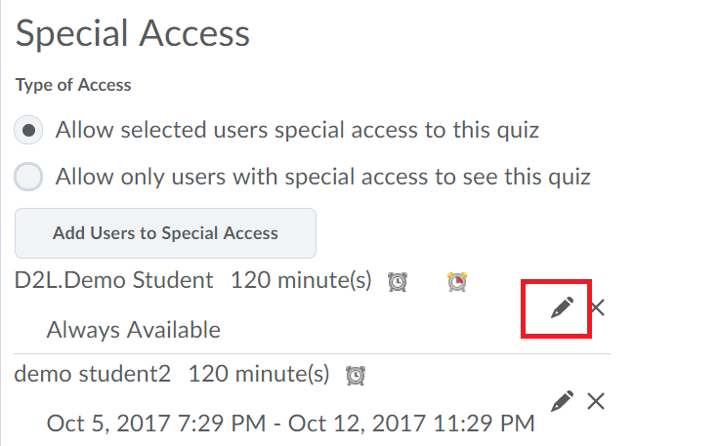

- Once complete, click Add Special Access.

- If a student has been given special access but need to be removed, click the X by their name to remove them.

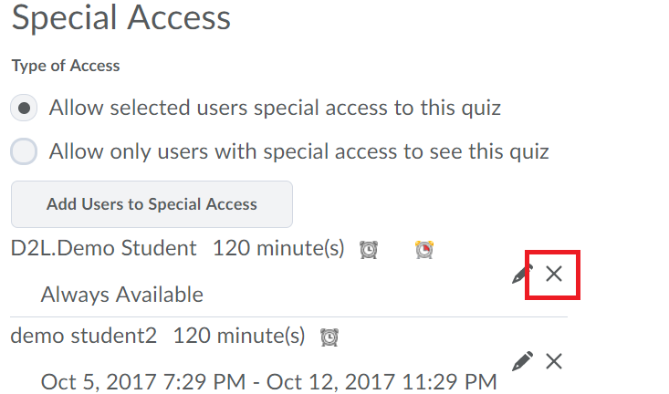

- When complete, click Save or Save and Close.

