Grading with a Rubrics
- Click on “Activities” on the Navbar.
- Select “Assignment Dropbox”.
- Click on the name of the submission folder you wish to grade. In my example, I will be using the “Service Learning Project” assignment.
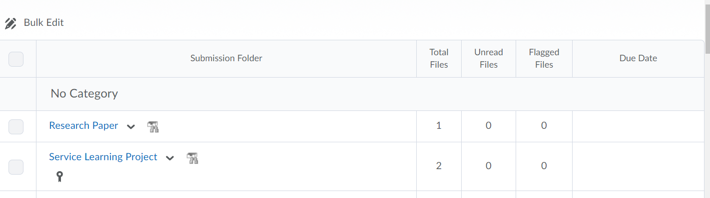

- Scroll down and the students and their papers will appear.
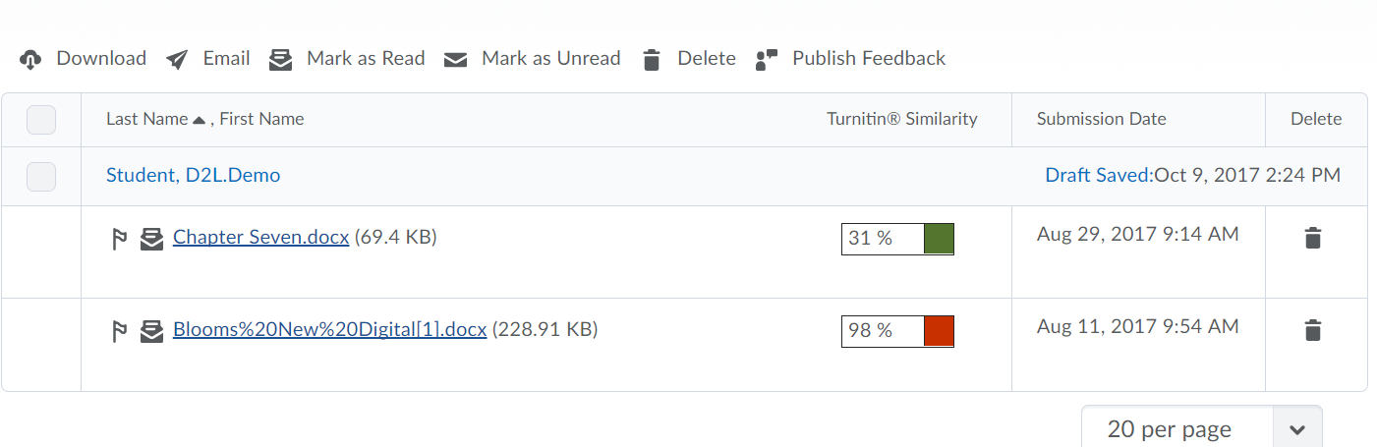

- Click on the name of the assignment you wish to grade.
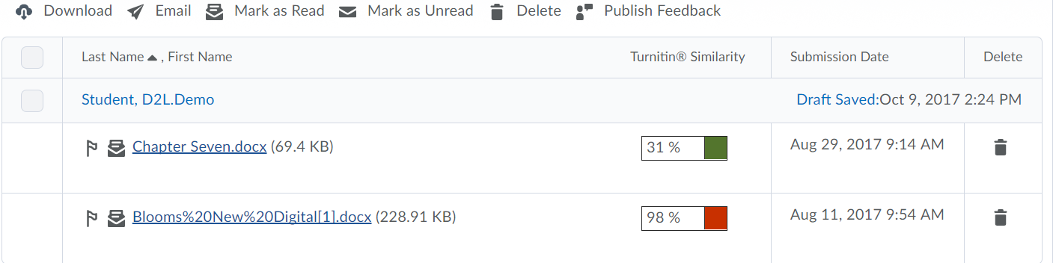

- You will now arrive at the “Evaluate Submission page”. You will see several scroll bars. Use the scroll bar under the small box next to the large scroll bar on the right hand side.
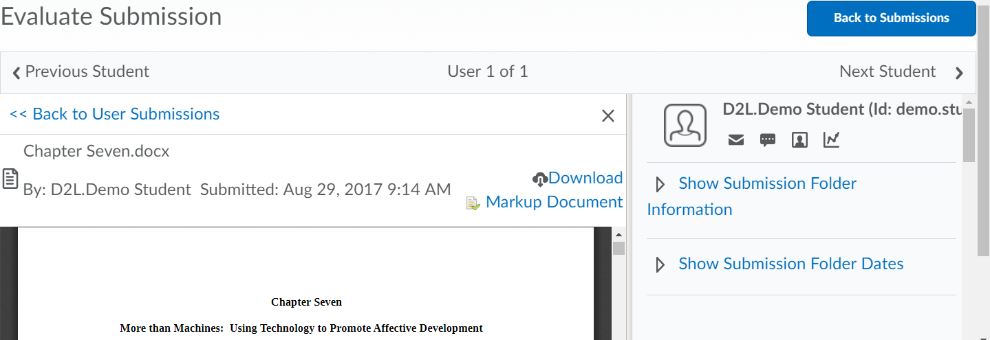

- Scroll down to “Evaluation” and you will see the name of the Rubric and click on the name.

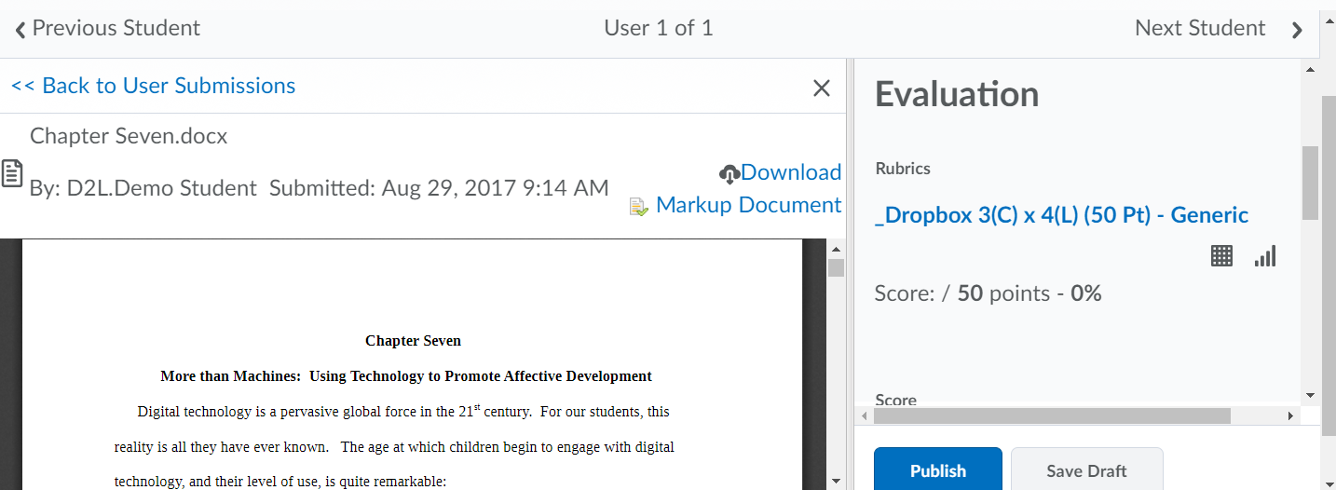

- A pop-up will appear.
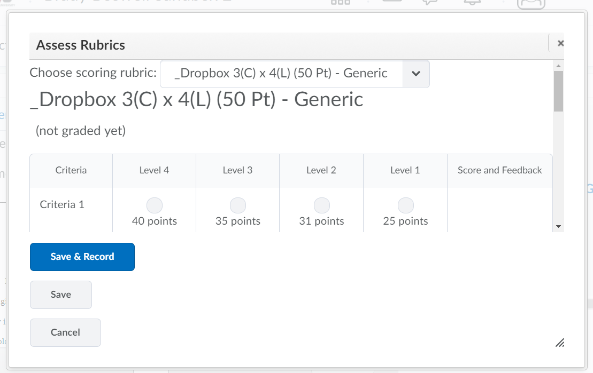

- Simply click on the radio button for all items. In my example, I am clicking on the 40 points.
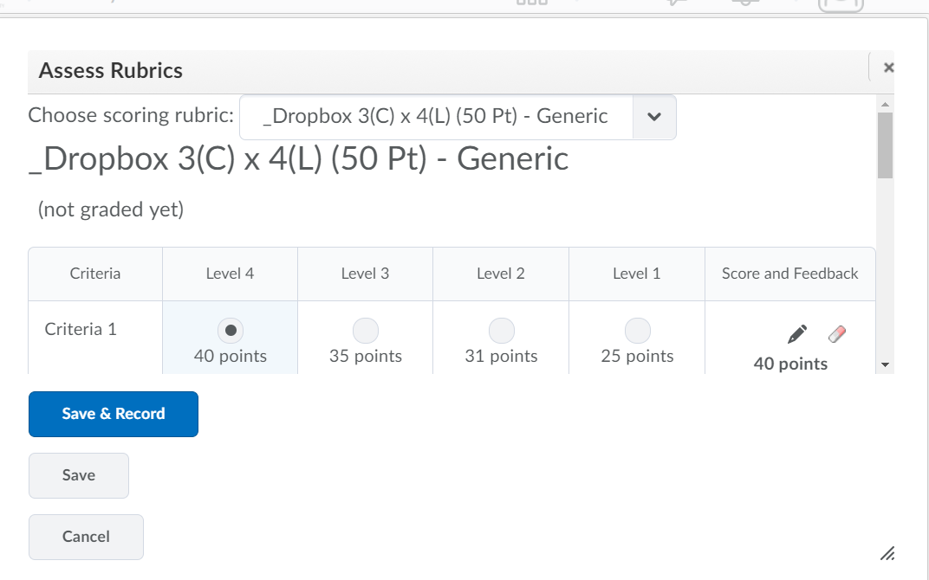
- When your done grading click “Save & Record”.

- You will see the score populate and click “Publish” to push it over to the Gradebook.
