Grading a Dropbox Assignment

1.) Navigate to the assignment dropbox using the Activities dropdown menu.
2.) Select "Assignment Dropbox".

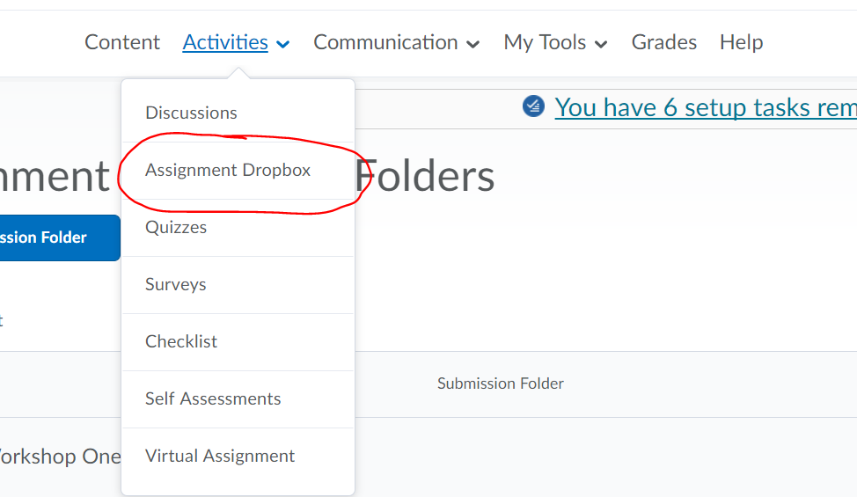

3.) If there are any new or unread files submitted in the dropbox, it will be noted.

4.) Click the arrow next to the dropbox you need to access.
5.) Select "View Submissions".

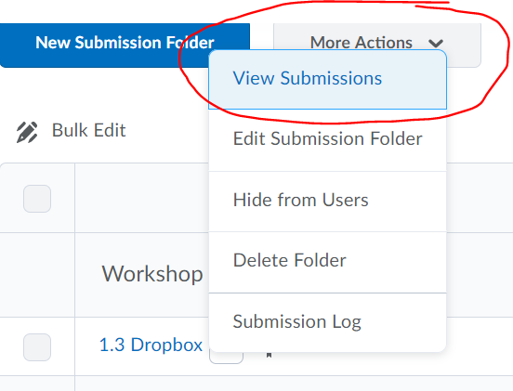
6.) The default tab for viewing the submission is view "Users".
7.) Scroll to the bottom of the page to locate the submissions.
8.) The date and time of the submittal is located on the right of the page.

8.) Click on the submitted file.

9.) From here, you will be able to either view as plain text, or if needed, download the file.

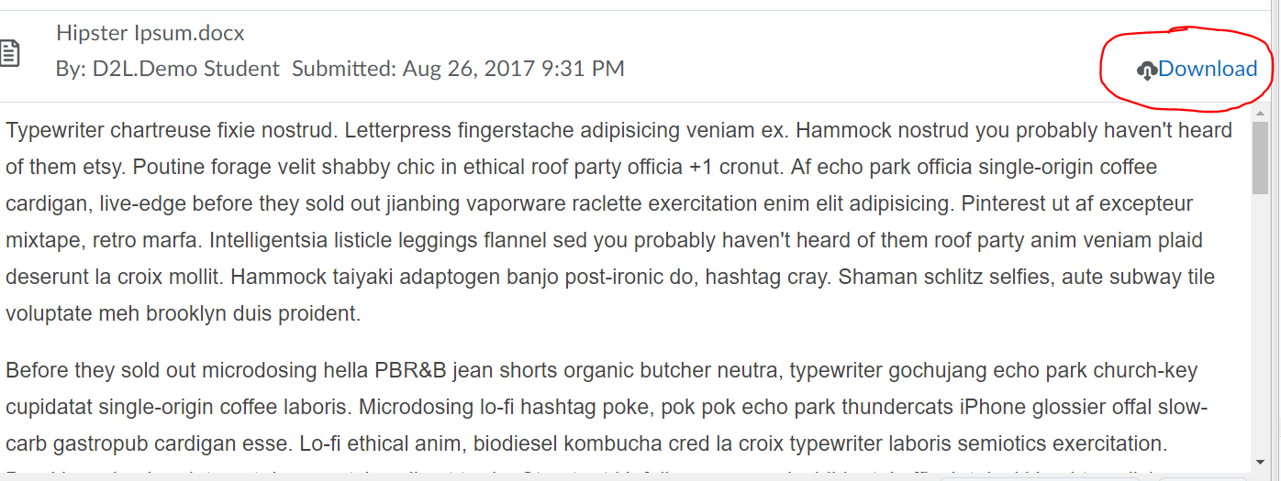

10.) On the right of the screen there are 3 icons under the student name.
a.) The first will allow you to send an instant message to the student.

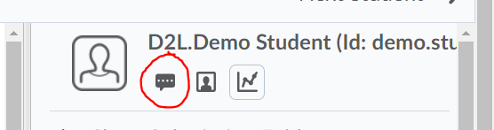

b.) The second will allow you to view the profile of the student.

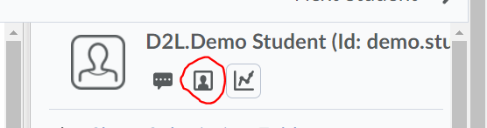

c.) The third will allow you to view the overall progress of the student.

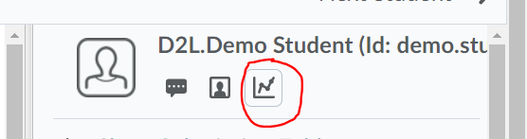

11.) Clicking on the arrow next to "Show Submission Folder Information" will expand that section to view the details for the assignment.

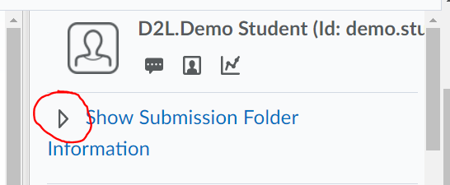

Clicking it again, will collapse the information.

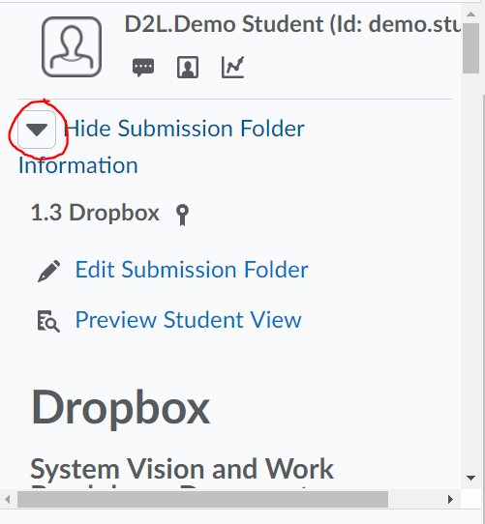

12.) Clicking on the arrow next to "Show Submission Folder Dates" will expand that section to view when the submission can be turned in.

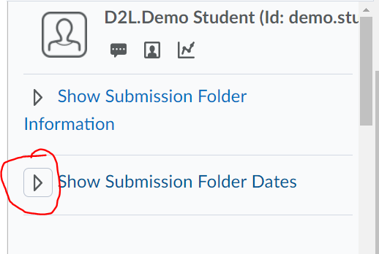

Clicking it again, will collapse the information.

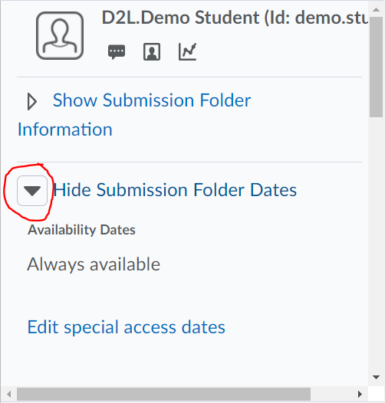

a.) Clicking on "Edit special access dates" will allow you to edit the time for the submission for this student.

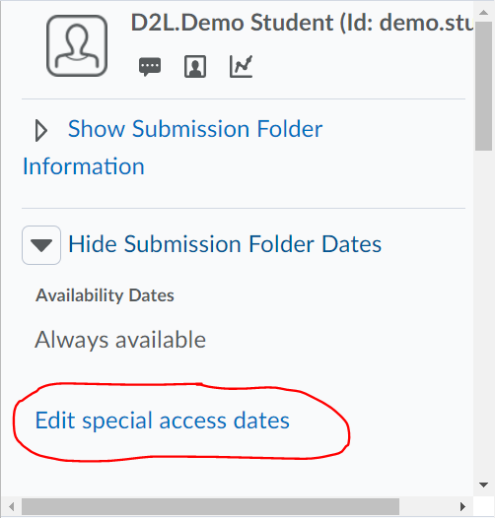

12.) Below this area is the Evaluation.
13.) You can enter in a score for the submission.

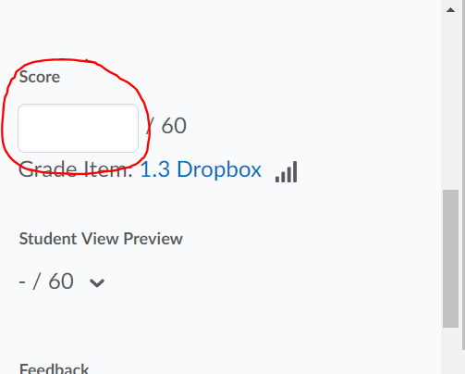

14.) Feedback can also be provided for the grade item in a number of ways.
a.) Feedback can simply be typed into the text box.

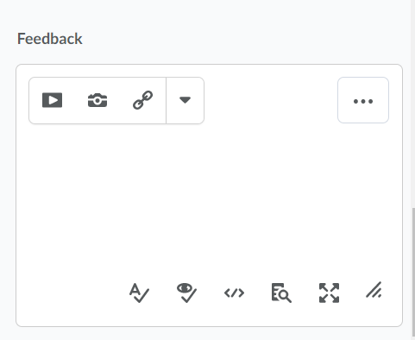

b.) Feedback can be submitted via an external file (Ie: Microsoft Word, Excel, etc.) using the "Add a File" button.

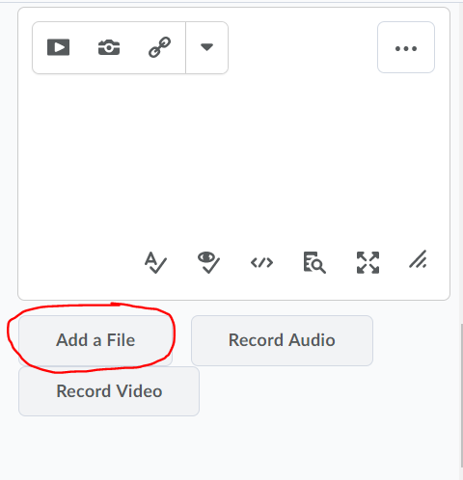

c.) An audio file can be submitted as feedback using the "Record Audio" button.

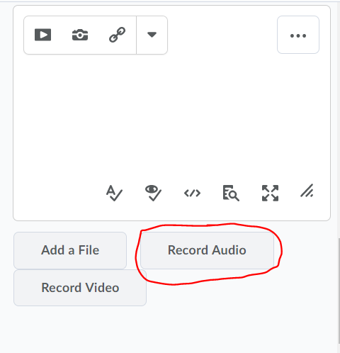

d.) A video file can be submitted as feedback using the "Record Video" button.

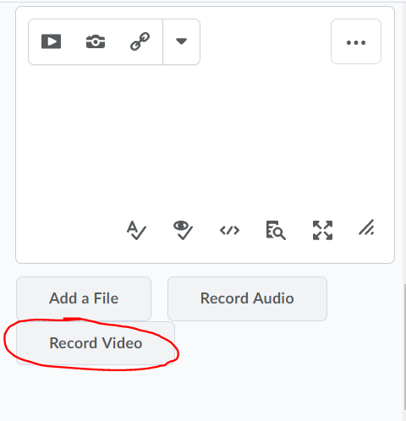

15.) When completed, click the "Update" button to submit the completed grade item.

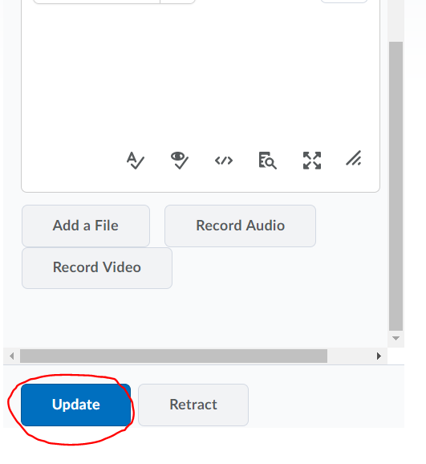

16.) If any corrections need to be made after you've clicked update. The "Retract" can be clicked to allow you to make changes. Once the corrections have been made, clicking "Update" again will save and publish the changes.

