Email Using the Classlist
- Click on “Communication”.
- Select “Classlist”.
- Scroll down to the list of everyone in the course and place a check in the first box to select everyone or choose an individual by placing a check in the box next to their name. Yes, you can also click on the gray “Email Classlist” button, but there will be an extra step.
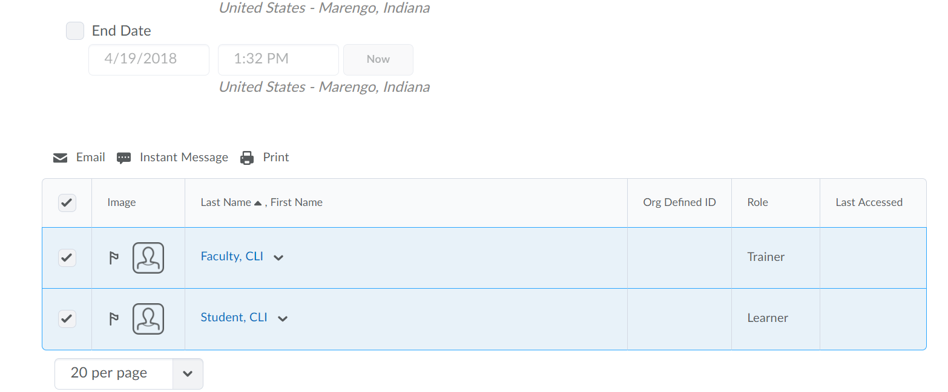

- Once everyone is selected click on “Email”.

- A pop up will appear. Compose your message and press the blue “Send” button at the top. You can also record an audio or video and add attachments.

