Class Progress
The Class Progress feature allows faculty to quickly see how students are doing in a course.
- Click on the “Grades” tab and select “Class Progress”.
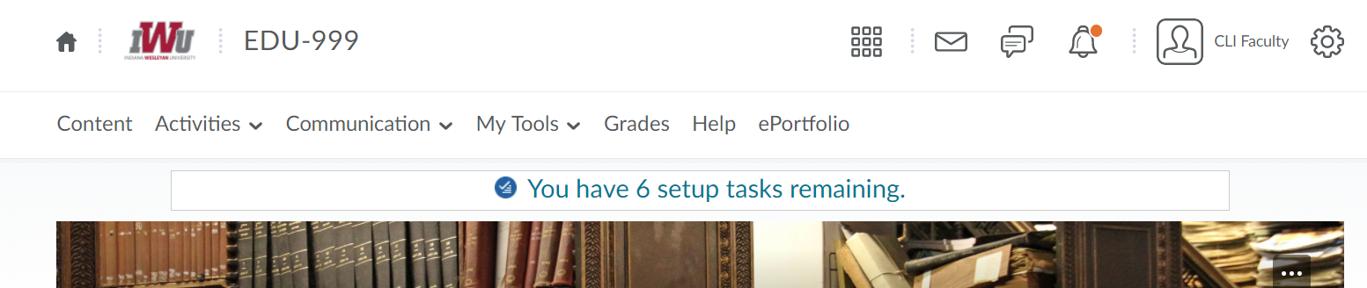

- A list of your students and their progress will be displayed.
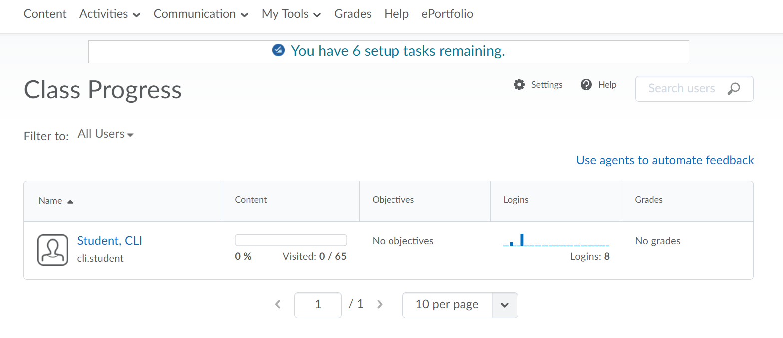
- To view more specific data on a certain student, click on the name of the student.
- The data for the individual student will be displayed and click an item on the left menu bar to drill down to more specific data on the individual item.
