Feedback for Students
Providing feedback to students is an essential component in the learning process. Feedback should surpass the simple “Great Job” or “Keep Trying”, it should provide students with a guide on where to go next and what to focus on. Feedback should also be delivered in a nonjudgmental and positive way. Student success increased? Yes, please!
Why does it seem so hard for students to see feedback?
In LearningStudio, students would go to the gradebook to view grades and feedback. In Brightspace, faculty have the opportunity to provide feedback in different areas inside a course and in different modalities. Often faculty have their own “rhythm of flow” to grading and providing feedback. This is where the confusion and disconnect come into play. The options are nice to have but can confuse students when they are not sure where to look.
How can I make this easier on my students and myself?
Feedback Placed Here | Student View/Access Feedback Here
Feedback placed in the Rubric for an Assignment Dropbox submission (Evaluate Submission page) | Class Progress and/or Assignment Dropbox item under Activities
Feedback placed in the feedback box for an Assignment Dropbox submission (Evaluate Submission page) | Class Progress and/or Assignment Dropbox item under Activities
Feedback placed for a Discussion | Gradebook and/or Discussion
Feedback placed in a Quiz | Quizzes (choose attempt if multiple attempts allowed)
Turnitin Feedback | Turnitin
Feedback placed in the General Feedback area | Gradebook
Overall Feedback (visible to all) | Gradebook

Feedback left on the Evaluate Submission Page
Students will find feedback left in a rubric associated with an assignment or in the general area in Class Progress.
The images below show that when feedback is left in the rubric or in the feedback area (Image 1), it will show up for the students in Class Progress (Image 2). This includes video and audio feedback. NOTE: If Turnitin is used, the feedback is viewed inside the Turnitin system.
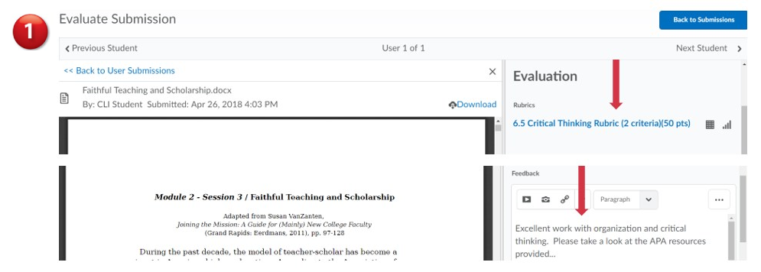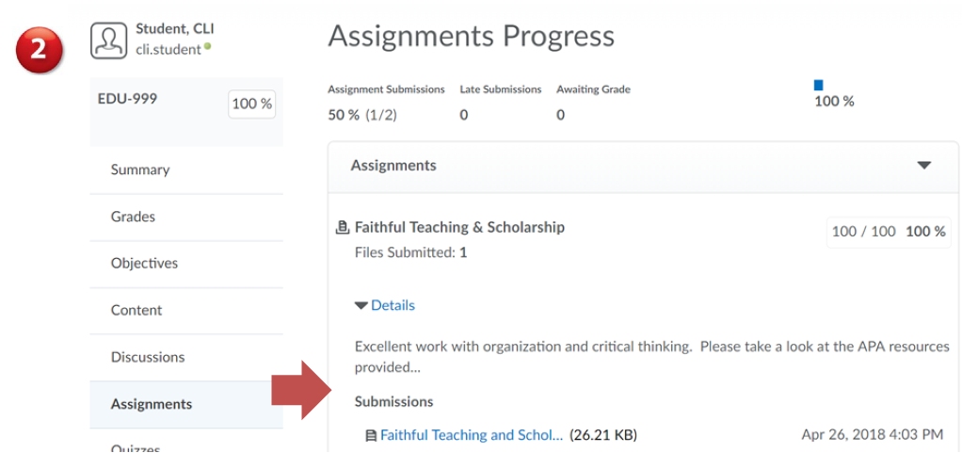
**Feedback found in the general feedback area can also be viewed in the gradebook but will not have the rubric.

Providing Feedback using Video Note for a Discussion
You can provide quick and easy feedback using Video Note. The feedback cannot exceed three minutes and is recorded straight from your computer. You may also upload previously recorded feedback.
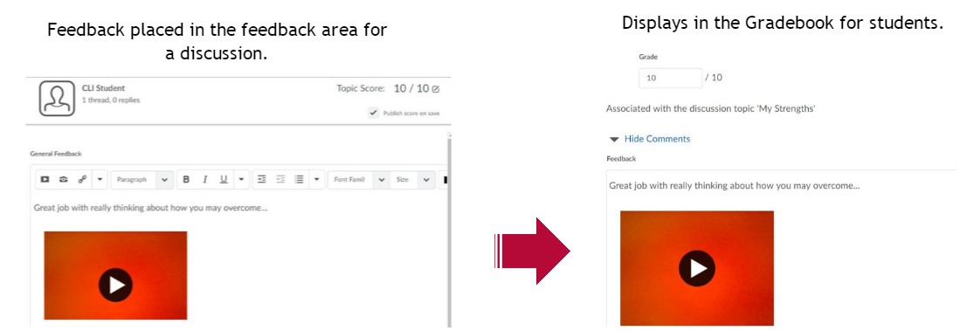

For more information on Video Note, please visit https://kb.indwes.edu/Web/Academic/Brightspace/Faculty_Guide/Video_Note .

Feedback provided for a Quiz
If feedback has been provided and the submission view has been set to allow students to see which questions they missed and/or which they got correct, they can view this information inside the quiz attempt.
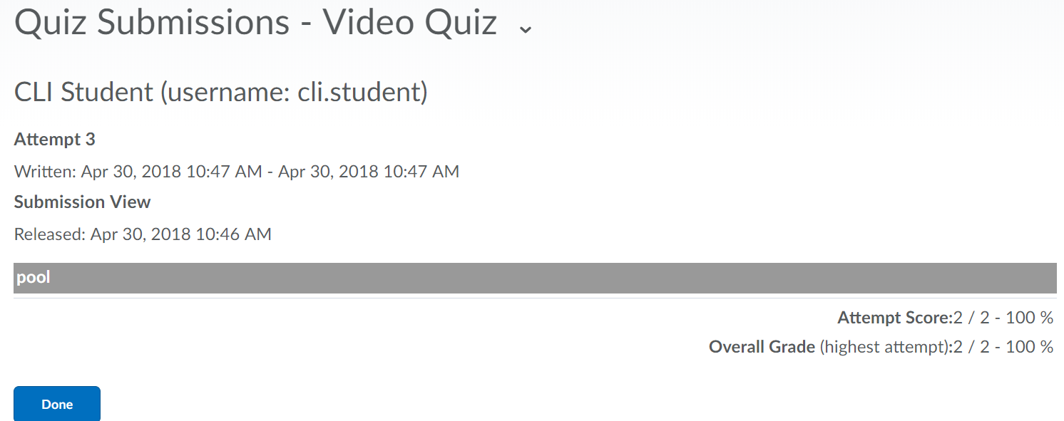

Please feel free to contact the Center for Learning & Innovation for more information.

