Respondus 4.0
User Guide for Desire2Learn Personality
rev. May,2013

Getting Started
Computer Requirements
Installation & Setup
Activation Password
Choose a Learning management system (LMS) Personality
On-line Help

Start Menu
Overview
Opening a File
Creating a File
Test Bank Network
Exam Wizard
Importing Questions to Respondus
Archive Wizard
Changing the LMS Personality and Converting Files

Editing a File
Overview
Common Features Across all Question Types
Question List and Expanded View
- Multiple Choice
- True or False
- Long Answer
- Matching
- Short Answer
- Multi-Select
- Ordering
- Fill in the Blanks
- Arithmetic
Adding Bold, Italics, Underline, and Super/Subscript
Media Wizard
HTML Editor
Equation Editor
Power Edit
- Tables
- Fonts, Formatting and Lists
Spell Check
Keyword Searches

Settings Menu
Overview
Properties
Restrictions
Attempts / Submissions
Layout
Random Sections
How to Save New Default Settings

Preview & Publish
Overview
Preview
Publish
Print Options

Retrieval
Overview
Retrieving a Quiz from Desire2Learn

Other Tools & Features
Overview
Save As Copy
Save As StudyMate Class Format
Preferences
Update License
Cleanup HTML Tool
Question Title Tool
Check for Update

Disclaimer of Warranty

Copyright, Ownership, and Use of Software

Getting Started
Computer Requirements
Installation & Setup
Activation Password
Choose a Learning management system (LMS) Personality
On-line Help

Respondus is a powerful tool for creating and managing exams that can be printed to paper or published directly to Blackboard, Desire2Learn, eCollege, WebCT, and other eLearning systems. Exams can be created offline using a familiar Windows environment, or moved from one eLearning system to another. This version of the user guide is specifically intended for people using the Desire2Learn “personality” in Respondus.

Computer Requirements
Respondus requires Windows XP or higher, 32 MB of RAM, 10 MB of free hard disk space, and a 800x600 monitor (1024x768 recommended). Respondus is generally used in conjunction with a learning management system such as ANGEL, Blackboard, Desire2Learn, eCollege, WebCT, and can also be used with IMS QTI-compliant assessment systems.

Installation and Setup
The Respondus installation program can be downloaded from www.respondus.com. To begin the installation process, locate the installation file that was downloaded to your hard drive (eg. Respondus4.exe), double-click the file, and follow the instructions shown. Once Respondus is installed, start the program by double-clicking the Respondus icon that appears on the Windows desktop. Or, follow these steps to start the software.

Click [Start] from the Windows desktop
Click [Programs]
Click [Respondus]
Click [Respondus X.x]

The first time you start Respondus (and each time thereafter until the program is registered), you will be presented with a screen that provides the “Product ID#”. The Product ID# is used to obtain the Activation Password (see below) which is needed to complete the installation.

Activation Password
Once the Respondus installation program is finished, you will need to obtain a password from www.respondus.com to activate the installation. Be sure to have the “Product ID#” (see previous paragraph) readily available. After you have directed your browser to www.respondus.com, go to the “Registration” section. You have the choice of purchasing a permanent activation password or obtaining a 30-day trial password. In both cases you will be required to enter a valid e-mail address and the Product ID# that displays on the opening screen of Respondus. Once the information is submitted, the activation password is immediately sent to the e-mail address you specified.

When the password is received by e-mail, it must be entered into the Respondus program. If you haven’t done so already, start Respondus and then enter the password when prompted (you may want to “copy and paste” the password from the e-mail message in order to prevent typing mistakes). Click [OK] to continue. The Respondus software is now activated, either permanently or for a 30-day trial period.

Choose a Learning management system (LMS) Personality
Immediately after the Respondus software is activated, you are prompted to select a Learning management system (LMS) “personality.” Respondus offers various user environments (called “personalities”) that parallel the features and terminology used by specific learning management systems, such as Blackboard, eCollege and Desire2Learn. You can change the “personality” at any time in Respondus from the Start menu.

On-line Help
Respondus includes a full-featured help system that includes an index and context-sensitive help. To view the on-line help, choose “Help Topics” from the pull-down Help menu and select a topic. You can also press the F1 key from within Respondus to obtain context-sensitive help. Throughout the program you will additionally see small buttons having a “?” symbol. When the button is clicked, information on that particular option or task is provided.

If you encounter a question that is not answered in the on-line help or in this manual, you are encouraged to visit the “Support” section of the Respondus web site (www.respondus.com). There you will find a knowledgebase and other resources.

The remainder of this user manual is organized according to the five menus used in the “Desire2Learn” personality of Respondus: Start, Edit, Settings, Preview & Publish, and Retrieval.

Start Menu
Overview of Start Menu
Opening a File
Creating a File
Test Bank Network
Exam Wizard
Importing Questions to Respondus
Archive Wizard
Changing the LMS Personality and Converting Files

Overview of Start Menu
The Start menu provides the ability to Open a Respondus file, Create a new file, access publisher test banks from the Respondus Test Bank Network, and Import questions from a MS Word or text file. The Exam Wizard provides an easy way to create an exam from an existing set of questions. The Archive Wizard allows you to archive an exam or survey, including all media components and equations, with a single click.

Opening a File
From the Start menu, click the Open button. The following window will appear:

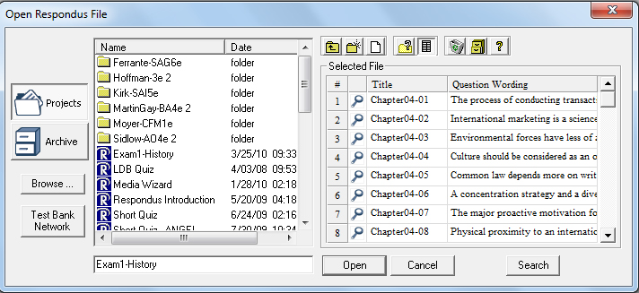

Highlight an exam project by clicking it once. To obtain information on the project, select either of the two center buttons located to the top right of the file list. Select the “Item List” button (right of center) to view a list of the questions that are available in the highlighted project. To preview a particular question, click the “Title” of the question.

To open a highlighted project, click the [Open] button at the bottom of the window. (Double-clicking a file name will also open it.)

Respondus allows projects to be organized within folders. For example, you can place the exams for a particular course within a folder rather than having exams for all courses listed together. To create a new folder, click the “Create New Folder” button located second from left. To navigate down a level within a folder, double-click on the folder itself. To navigate up a level, click the “Up One Level” leftmost button on the row.

The [Browse…] button, located on the lower left side of the window, allows you to locate a Respondus file (.rsp) located elsewhere on your hard drive and copy the file to the Respondus Projects folder. It does not move the file or open it directly, rather, it creates a new “Projects” folder based on a copy of that file. The [Browse…] button can also be used to locate a Respondus “archive” file (.rsa or .rpa) and to restore it to the Projects directory (see Restoring an Archive File).

The [Search] button allows a file to be searched prior to opening it (it can only be used if the “Item List” view is selected). Searching is particularly useful if you are trying to locate a particular question or set of questions in a file.

The [Test Bank Network] button is used to start the Respondus Test Bank Network wizard. The Respondus Test Bank Network contains the official test banks for thousands of publisher textbooks. Instructors who adopt a participating textbook can access the accompanying test bank directly within Respondus (following a registration process). For complete details, see the “Respondus Test Bank Network” at www.respondus.com.

Once a file is opened, the screen automatically changes to the Edit menu.

Creating a File
From the Start menu, select the Create button to create a new file. You are first prompted to enter a file name and a description for the file. Click [OK] when you are finished. Once a file is created, you are automatically switched to the Edit menu. This is where you add questions to the file.

Test Bank Network
The Respondus Test Bank Network contains the official test banks for thousands of publisher textbooks. Instructors who adopt a participating textbook can access the accompanying test bank from within Respondus by selecting the Test Bank Network button on the Start menu.

Note: all interactions with the Test Bank Network require an internet connection.

The Test Bank Network wizard allows instructors to search for a publisher test bank, submit a request form for the test bank, register a test bank using the registration code and password sent by the publisher, and finally, select questions from the test bank for use in a Respondus file.

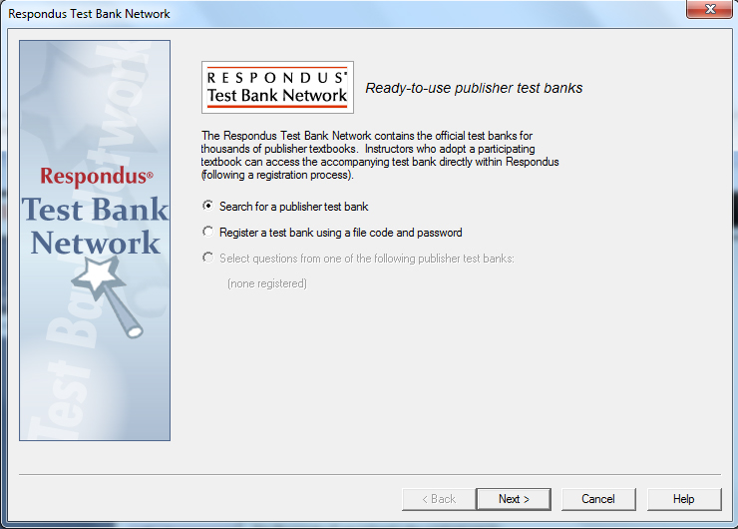

The first selection “Search for a publisher test bank” will open a browser window and enable instructors to search for textbooks adopted for their classes. Once a textbook is located, a request form is filled out and submitted. This information is sent directly to the publisher for verification.

The textbook publisher will send an email to the instructor containing a “file code” and password for registering the test bank using the Respondus software. The instructor should then return to the Test Bank Network wizard in Respondus to register the test bank, which is the second option listed: “Register a test bank using a file code and password”.

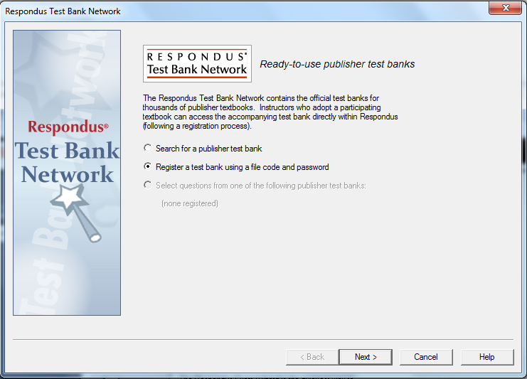
In the next step of the wizard, enter the “File Code” and “File Password” (if required) provided by the publisher, along with the information requested. This will register the test bank with this copy of Respondus. It won’t be necessary to repeat the process on this computer.

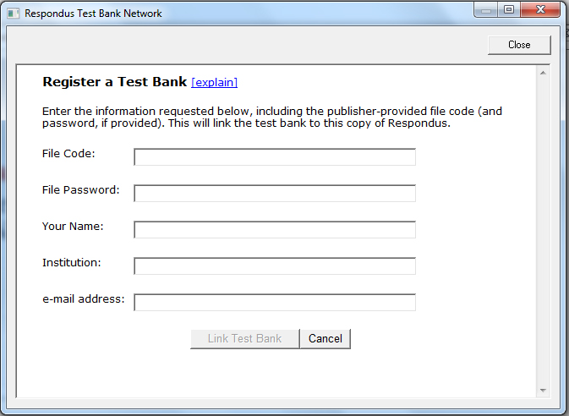

Once the test bank has been registered in Respondus, the third option on the Test Bank Network wizard become available: “Select question from one of the following publisher test banks:”.

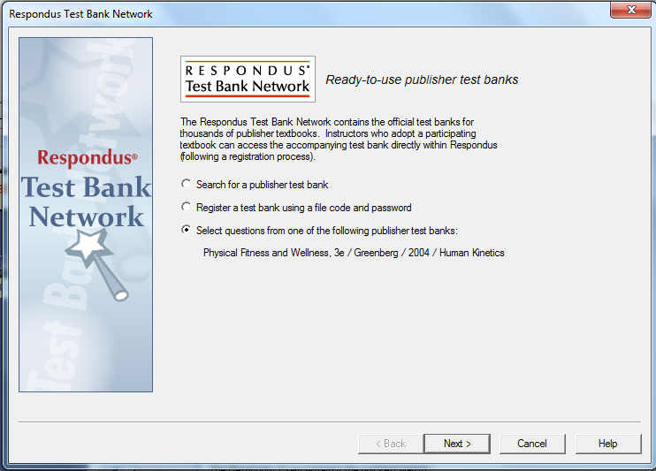

The next page of the wizard allows the selection of a registered test bank and then a specific chapter file from the test bank.

Questions can be manually selected or automatically selected depending on the Question Selection toggle. With Manual selection, individual test bank questions can be previewed and copied to the current Respondus project. To do so, simply select the box to the left of the questions wanted and click the “Add to End of List” or “Insert into List” button.

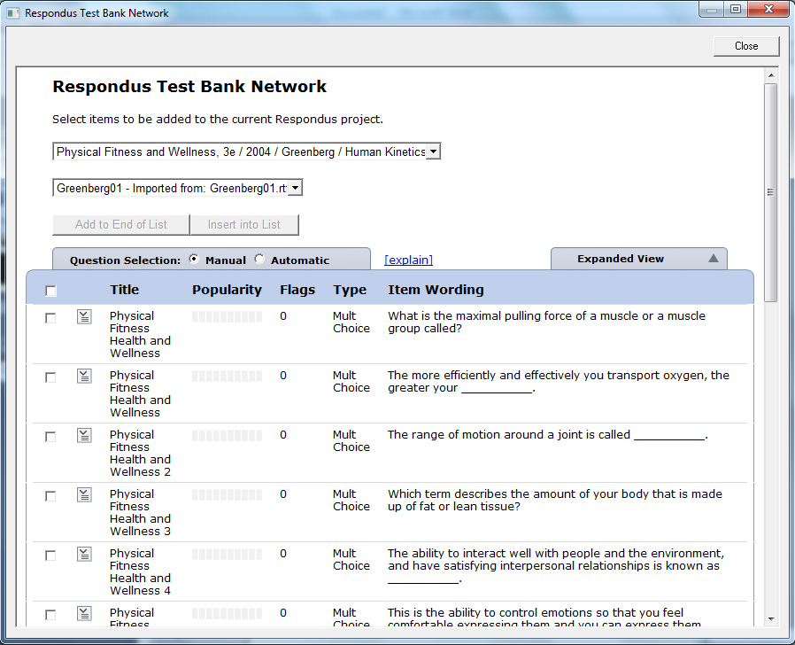

Each question listed has a context menu that provides the following operations:

Preview – Preview the question.
Add to End of List – Add this question to the end of the list.
Insert into List – Insert this question into a specific point in the list.
Flag this item – Flag this question as being incorrect or unclear.
Properties – View the properties for the question.

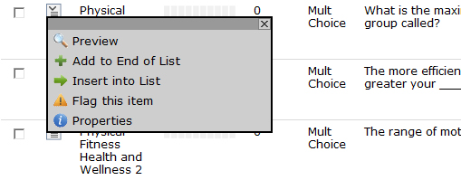

Questions that have been flagged (by any instructor using the test bank) will appear with a flag next to the item in the list. The contents of the flag can be viewed by hovering the mouse over the flag or clicking it.

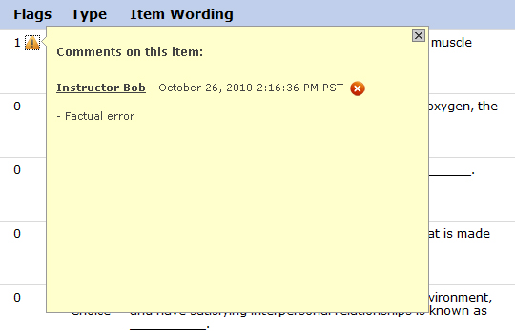

When Automatic selection is used, the number of available questions of each question type is shown. Enter the number of questions to be selected for each question type and the point value to be assigned to it.

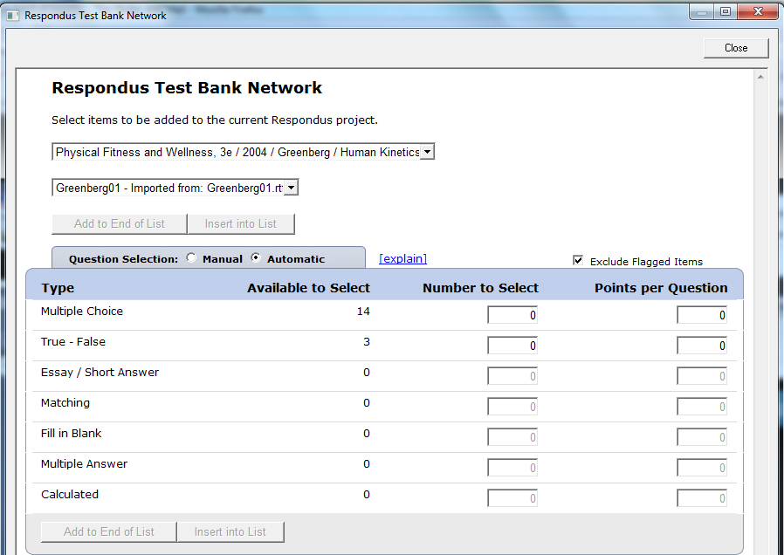

Questions copied from the test bank using either Manual or Automatic selection will be copied to the currently open Respondus file.

Exam Wizard
The Exam Wizard helps familiarize new users with the basic functions of Respondus. In addition, the Exam Wizard is the best way to create an exam using questions contained in one or more Respondus files, such as a publisher test bank. The Exam Wizard allows questions to be randomly selected from other files and point values to be assigned across an entire question type.

To begin, select the Exam Wizard button from the Start menu. The first page of the wizard offers three choices. Select the top choice that states “Create a new exam and then copy questions to it from a question bank or Respondus file” and click [Next]. The next page of the wizard requires you to provide a name and description for the exam being created. Click [Next] once this information has been entered. The next page of the wizard prompts you to select the Respondus files from which the questions will be copied. Highlight a file and click the [Select] button. Repeat this process until all files from which you want to select questions are selected. Click [Next] to continue.

The next page of the wizard prompts you to select one of the source files chosen in the previous step. You then have the choice of using Automatic Selection or Manual Selection. When Automatic Selection is chosen, the current number of questions for each question type is displayed in the “Available to Select” column. In the next column, enter the number of questions you want selected for each question type. Then enter the point values to be assigned to each question type (this step is optional--if you leave the “points per question” field blank, the point values from the original file will be used). When all entries are finished, click either the [Add to End of List] button or the [Insert Into List] button. Repeat this process for each source file.

The Manual Selection option allows the questions for each file to be viewed before making a selection. In fact, you can preview individual questions by clicking the title of a question, or by searching the entire list of questions by clicking the [Keyword Search] button at the top right. To select questions from this list, simply click in the column furthest to the left--a checkmark will appear next to the question. When finished with your selections, click either the [Add to End of List] button or the [Insert Into List] button. Repeat this process for each source file.

The Automatic Selection and Manual Selection options may be combined. You may also reselect a file from the pull-down list and choose additional questions from it. However, Respondus will prevent you from selecting a question more than once.

Once questions have been added to the list at the bottom of the screen, you may edit the point values manually. To delete a question from the bottom list, or to move it to a different location in the list, click the blue title and select the desired option. Finally, notice that a tally of the total number of questions and point values appears at the top right corner of the lower grid.

The next and final page of the wizard is self-explanatory. It provides a variety of options as to what can occur next. For example, to edit questions in the file, you would select the option to go to the Edit menu. To preview the exam, you would select that option, and so on.

Click [Finish] to complete the wizard.

Importing Questions to Respondus
Respondus allows you to import multiple choice, true-false, essay, fill in the blank, fill in multiple blanks, matching, ordering, jumbled sentence, and multiple answer questions from a file. The questions must be organized in a format that is acceptable to Respondus and the file must be stored in one of the following formats: plain text (.txt), rich-text (.rtf), MS Word (.doc and .docx), tab/comma delimited (.csv) format, StudyMate Class format (.zip and .xml).

Note: Importing questions from the Microsoft Word .docx format requires that Word 2007 or Word 2010 be installed on the same computer. The docx format has better support for importing text with formatting like auto-numbers and auto-letters.

The formatting required for the file being imported is discussed in the section below entitled “The Standard Format for Importing.” Once the file is in the Standard Format, follow these steps to import it into Respondus.

Starting the Import
From the Start menu, select the [Import Questions] task. A window will appear:
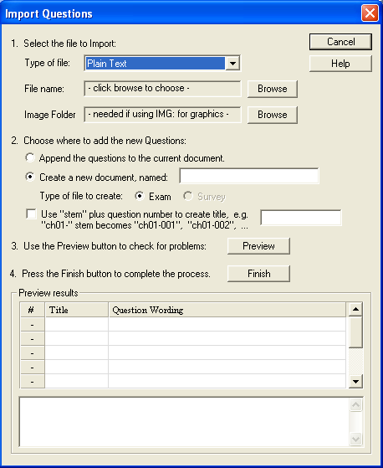

Step 1
The first step is to select the type of file that will be imported. The “Standard Format” for organizing questions is the same for Plain Text (.txt), Rich Text (.rtf) files, and Microsoft Word (.doc and .docs) files. Files that are in rich text (.rtf) and MS Word (.doc and .docx) format will retain some of the enhanced question formatting such as bold, italic, underline, superscript, and subscript. Embedded graphics can only be imported if the file is in Microsoft Word (.doc or .docx) format, although an alternative method is available for .rtf and .txt files (see Importing Images below). Note that certain types of enhanced formatting cannot be imported. If the enhanced formatting causes a problem with an import, consider saving the file to rich text or plain text format and then try the import again.

Next, use the [Browse] button to locate and select the file to be imported.

Images embedded in MS Word files will import automatically. However, if images are being imported with csv, rich-text, or txt files (see Importing Images below), browse to the folder that contains those images.

Step 2
Specify whether the questions should be appended to the currently open file or whether to create an entirely new file. If you select the second option you will need to enter the name of the file to be created.

Each question being imported will have a “title”. If you don’t specify a title for each question in the text file itself (discussed below), Respondus will automatically use the first 20 characters of the question wording as the question title. Alternatively, titles can be based on a specific “stem” (or string of text) which will then be followed by consecutive numbering starting with 001. For example, if you select the “Use stem...” checkbox and enter the text “Chapter1-”, the title for the first question being imported will be Chapter1-001, the title for the second question will be Chapter1-002, and so on. (You are not required to enter a stem phrase--this feature is entirely optional.)

Step 3
Click the [Preview] button to preview the file being imported and to see if there are any warning messages. If warning messages are shown at the bottom of the screen, you need to determine whether to make changes to the text file or whether to continue with the import. Be aware that some warning messages don’t actually require you to make a change to the file being imported. For instance, Respondus will generate a warning message if two questions being imported have the same title (Respondus will place the number “2” at the end of the second title to make it distinct from the first). But if you don’t care about this issue, you can ignore the warning message.

Step 4
If you are satisfied with how the results look in Preview, click [Finish] to complete the import. The Respondus file has now been created or appended. Switch to the Edit menu to modify the file, or go to the Preview tab to view the file using a browser-like window.

The Standard Format for Importing
Respondus will import multiple choice, true or false, essay (long answer), fill in blank (short answer), and multiple response (multi-select) questions. (In this documentation, the terms “long answer” and “essay” will be used interchangeably; the terms “short answer” and “fill in blank” will be used interchangeably; and “multiple response” and “multi-select” will be used interchangeably. The reason for this is to use terminology that is similar with other Respondus documentation and products.)

The plain text, rich-text, or MS Word file must be organized in a “Standard Format” before it can be imported into Respondus. The Standard Format for multiple choice questions has required elements and optional elements, each of which is described below. This section is followed by an explanation of the formatting required for true or false, essay, fill in blank, and multiple response questions.

Required Elements (Multiple Choice)
Each question must begin with a question number, followed by either a period “.” or a parentheses “)”.

Example: 3)
Example: 3.

The question wording must follow the question number. (Note: at least one space should be between the question number and the question wording.)

Example: 3) Who determined the exact speed of light?
Example: 3. Who determined the exact speed of light?

Each answer must begin with a letter (A-Z) followed by a period “.” or a parentheses “)”.

Example: 3) Who determined the exact speed of light?

a. Albert Einstein
b. Albert Michelson
c. Thomas Edison
d. Guglielmo Marconi

Optional Elements (Multiple Choice)

A Title can be imported with each question. If a title is not provided for a question, the first 20 characters from the question wording will be used as the question title. Titles must be placed at the beginning of a question and begin with “Title:” followed by the actual text for the title. If the title exceeds 20 characters, the remaining characters will be dropped during the import.

Example: Title: Speed of Light
3) Who determined the exact speed of light?

a. Albert Einstein
b. Albert Michelson
c. Thomas Edison
d. Guglielmo Marconi

For questions being imported to an Exam file, correct answers can be indicated in two ways. First, you may place an asterisk (*) directly in front of the answer choice (do not put a space between the asterisk and the answer choice).

Example: Title: Speed of Light
3) Who determined the exact speed of light?

a. Albert Einstein
*b) Albert Michelson
c) Thomas Edison
d. Guglielmo Marconi

The second option is to place a list of correct answers at the end of the file. The list must begin with the word “Answers:” and the answers should start on the following line (no blank lines are allowed). Note that any text after the answer list will be ignored.

Example: Answers:
1. A
2. C
3. B

If neither method is used to select a correct answer, Respondus will automatically select the letter “A” as the correct answer. Don’t worry, you will be warned if a question does not have an answer selected for it prior to completing the import.

Feedback for individual answer choices can be imported by placing the feedback immediately after the answer choice and by beginning the line with the @ symbol. There must be at least one space between the @ symbol and the feedback text.

Example: Title: Speed of Light
3) Who determined the exact speed of light?

a. Albert Einstein
@ No. Albert Michelson determined the exact speed of light.

*b) Albert Michelson
@ Yes. Albert Michelson won the Nobel Prize for Physics for determining the exact speed of light.

c) Thomas Edison
@ No, Thomas Edison did not determine the exact speed of light.

d. Guglielmo Marconi
@ No. Marconi did not discover the exact speed of light, but he did win the Nobel Prize for Physics for his work with radio waves.

General feedback, which provides feedback for an overall question (opposed to feedback for individual answers), must appear immediately after the question wording and before any of the answer choices. The line must also begin with the @ symbol, and there must be at least one space between the @ symbol and the feedback text.

Example: Title: Speed of Light
3) Who determined the exact speed of light?
@ Albert Michelson was the first American to win the Nobel Prize in Physics (1907) for his measurements of the speed of light. His experiments laid the groundwork for Einstein’s Theory of Relativity.

a. Albert Einstein
@ No. Albert Michelson determined the exact speed of light.

*b) Albert Michelson
@ Yes. Albert Michelson won the Nobel Prize for Physics for determining the exact speed of light.

etc.

As shown in the previous example, both types of feedback can be used within a single question (although this is not typically done).

Point values can be set for each question or for a group of questions. Points are set by adding “Points:” followed by a space and the point value. The points value is used for the next question and all following questions until a new point value is set.

Example: Points: 2.5

3) Who determined the exact speed of light?

....

4) Who determined the exact speed of sound?

Both questions 3 and 4 will be given a value of 2.5 points.

Importing True or False Questions
The process of importing “true or false” questions is similar to that used for importing multiple choice questions (see above). Both of the following examples are valid ways to format a true or false question for importing purposes.

Example: 3) Albert Michelson determined the exact speed of light?

*a) True
b) False

Example: 3) Albert Michelson determined the exact speed of light?

*a. T
b. F

It’s important to note that the “True” (or “T”) answer choice must be listed prior to the “False” (or “F”) answer choice in order for Respondus to recognize it as a true or false question type. (If “False” appears first in the list, the question will be imported as a “multiple choice” question).

To include a “title” or “feedback” with the true or false question, follow the same formatting rules described above for multiple choice questions. For instance,

Example: Title: Light speed
3) Albert Michelson determined the exact speed of light?
@ Correct. Albert Michelson won the Nobel Prize for Physics for determining the exact speed of light.

*a. True
@ Yes. Albert Michelson won the Nobel Prize for Physics for determining the exact speed of light.

b. False
@ The correct answer is True. Albert Michelson determined the exact speed of light and won the 1907 Nobel Prize for Physics for his efforts.

A second way to designate a correct answer for a true and false question is to place it in a list of correct answers at the end of the file. The list must begin with the word “Answers:” and must be positioned at the end of the file. (Note: Any text after the answer list will be ignored.) The correct answer for a true and false question can be designated in three ways: (1) the complete word “True” or “False,” (2) the letter “T” or “F,” or (3) the alphabetical letter “A” (for true) or “B” (for false). For example, the formatting of each of the following answers is acceptable for true and false questions in which all of the answers are “true”:

Example: Answers:
1. True
2. T
3. A

Importing Essay Questions
The logic for importing essay questions (named “Long Answer” questions in Desire2Learn) is similar to what is described for multiple choice and true or false questions. The primary difference is that the first line of formatting must begin with “Type: E”. This is followed by the “Title” (which is optional), the question number, and the question wording.

Example: Type: E
Title: Michelson-Morely experiment

4) How is the Michelson-Morely experiment related to Albert Einstein’s theory of relativity?

If you are importing an essay question, you can supply an answer two different ways. First, you may provide an answer immediately after the question wording, beginning the answer with “a.” or “a)” (without the quotes).

Example: Type: E
Title: Michelson-Morely experiment

4) How is the Michelson-Morely experiment related to Albert Einstein’s theory of relativity?

a) In 1887, Albert Michelson and Edward Morely carried out experiments to detect the change in speed of light due to ether wind when the Earth moved around the sun. The result was negative. They found the speed of light is always the same regardless of Earth's motion around the sun. Scientists were puzzled with this negative result, and they didn't know how to explain it. Albert Einstein came up with the answer in his famous second postulate in theory of relativity: that the speed of light (in vacuum) is always constant and absolute, regardless of its source's motion and observer's movement.

The second way to supply an answer for an essay question is to place it in a list of correct answers at the end of the file. As described above with multiple choice questions, the list must begin with the heading “Answers:” and must be positioned at the end of the file. The answer to an essay question should begin with the corresponding question number, followed by either a period “.” or a parentheses “)”. This is then followed by a space and then the answer.

Example: Answers:
1. A
2. C
3. B
4. In 1887, Albert Michelson and Edward Morely carried out experiments to detect the change in speed of light due to ether wind when the Earth moved around the sun. The result was negative. They found the speed of light is always the same regardless of Earth's motion around the sun. Scientists were puzzled with this negative result, and they didn't know how to explain it. Albert Einstein came up with the answer in his famous second postulate in theory of relativity: that the speed of light (in vacuum) is always constant and absolute, regardless of its source's motion and observer's movement.
5. B

Importing Short Answer Questions
To import a Short Answer question, the first line of formatting must begin with “Type: S”. This is followed by the “Title” (which is optional), the question number, and the question wording.

Example: Type: S
Title: Who invented television?
5. Who is known as the "father of television”?

You can import only one correct answer per question, but it is possible to enter multiple forms of that answer.

Example: Type: S
Title: Who invented television?
5. Who is known as the "father of television"?

a. Zworykin
b. Vladimir Zworykin
c. Vladimir Kosma Zworykin

Answers can also be placed at the end of the file, using a format similar to multiple choice questions. The only difference is that you can enter multiple forms of an answer by repeating the question number.

Example: Answers:
1. A
2. C
3. B
4. C
5. Zworykin
5. Vladimir Zworykin
5. Vladimir Kosma Zworykin
6. B

Importing Multiple Fill in the Blanks Questions
Fill in multiple blanks questions may be imported by starting the first line of formatting with “Type: FMB”. This is followed by the “Title” (which is optional), the question number, and the question wording with the words to be filled in provided in [square brackets]. The wording can include up to 10 [words] to be filled in, each of which can have up to 20 correct answers.

Example: Type: FMB
Title: Multiple blanks
5. A [rose] by any other [name] would smell as [sweet].

Respondus allows multiple correct answers per blank to be specified by separating each correct answer inside the brackets with commas.

Example: Type: FMB
Title: Multiple blanks
5. A [rose, red flower] by any other [name] would smell as [sweet, good].

General feedback can be imported by placing the @ symbol in front of the feedback. There must be at least one space to the right of the @ symbol and the text you want displayed for the feedback. The feedback must appear after the question wording

Example: Type: FMB
Title: Multiple blanks
5. A [rose, red flower] by any other [name] would smell as [sweet, good].

@ A rose by any other name would smell as sweet
– or – A red flower by any other name would smell as good.

Importing Matching Questions
The process of importing a “matching” question is similar to what is described for importing multiple choice questions, but there are some key differences. The first line of formatting must begin with “Type: MT”. This is followed by the “title” (which is optional), the question number, and the question wording.

Each answer (which consists of both parts of a correct match) must begin with a letter (a-z) followed by a period “.” or a parentheses “)”. The two parts of the match must be separated with an “=” symbol and there should not be any hard returns or blank lines within either parts of the answer.

Example: Type: MT
Title: Scientific discoveries

4) Match the correct name to the discovery or theory.
a. Michelson-Morely = Speed of light
b. Einstein = Theory of Relativity
c. Marconi = radio waves

Spaces before or after the “=” symbol are optional, but it is important that an answer only uses the = symbol for the purpose of separating the two parts of the match. If you plan to list correct answers for other questions at the bottom of the document, simply skip the number for all questions that are of the matching variety.

Importing Ordering Questions
Ordering questions may be imported by starting the first line of formatting with “Type: ORD”. This is followed by the “Title” (which is optional), the question number, the question wording, and the answer choices which must be in the correct order.

Example: Type: ORD
Title: Presidential Order
5. Put the following presidents in order of service?
a. George Washington
b. John Adams
c. Thomas Jefferson
d. James Madison
e. James Monroe

Each answer (which must be in the correct order) must begin with a letter (a-t) followed by a period “.” or a parentheses “)”.

Feedback can be imported by placing the @ symbol in front of the feedback. If feedback is placed before the first answer then it is imported as general feedback. If feedback is placed after an answer it becomes feedback for that answer.

Example: Type: ORD
Title: Olympic Order
5. Put the following Summer Olympic host cities in chronological order of when they hosted the Olympics?

@ Montreal, Moscow, Los Angeles, Seoul and Barcelona are the correct order.

- Montreal, Canada
@ Montreal 1976
b. Moscow, Soviet Union
@ Moscow 1980
c. Los Angeles, United States
@ Los Angeles 1984
d. Seoul, South Korea
@ Seoul 1988
e. Barcelona, Spain
@ Barcelona 1992

Importing “Multiple Response” Questions
The logic for importing questions that allow multiple responses (named “Multi-Select” questions in Desire2Learn) is similar to what is described above for importing multiple choice questions. (Multiple Response questions are, essentially, multiple choice questions in which more than one correct response can -- and generally should -- be selected by the student). The primary difference is that the first line of the formatting must begin with “Type: MR” (as an alternative, you can use “Type: MA” which stands for “Multiple Answers”). This is followed by the “Title” (which is optional), the question number, and the question wording. Each correct answer is designated with an asterisk.

Example: Type: MR
3) Which of the following individuals are credited with determining the exact speed of light?

a. Albert Einstein
*b. Albert Michelson
*c. Edward Williams Morley
d. Thomas Edison

To include a “title” or “feedback” with the Multiple Response question, follow the same formatting rules described elsewhere for multiple choice questions. For instance,

Example: Type: MR
Title: Determining Speed of Light
3) Which of the following individuals are credited with determining the exact speed of light?
@ Albert Michelson and Edward Williams Morley collaborated on a series of experiments that eventually led to the exact determination of the speed of light.

a. Albert Einstein
@ No. Albert Michelson and Edward Williams Morley collaborated on a series of experiments that eventually led to the exact determination of the speed of light.

*b) Albert Michelson
@ Yes. Albert Michelson is one of the two persons credited with determining the exact speed of light.

*c) Edward Williams Morley
@ Yes. Edward Williams Morley is one of the two persons credited with determining the exact speed of light.

(Note: this example illustrates how to include both “General Feedback” and answer-specific feedback. In most cases, you would include only one type of feedback.)

A second way to designate correct answers for multiple response questions is to place them in a list of at the end of the file. The list must begin with the word “Answers:” and must be positioned at the end of the file. If a question has been designated as a Multiple Response type using “Type: MR”, then correct answers can be listed three different ways: (1) placing a blank space between the letters representing the correct answers, (2) placing a comma between the letters representing the correct answers, or (3) placing a comma and a blank space between the letters representing the correct answers. For example, the formatting of each of the following answers is acceptable for multiple response questions.

Example: Answers:
1. B D
2. B, D
3. B,D

Important: Once the import file is organized to the specifications described above, it should be saved to MS Word (.doc and .docx), rich-text (.rtf) or a text (.txt) file. It is then ready to be imported by Respondus.

Importing Images with Questions
Images embedded in MS Word files will import automatically. However, it is possible to import images with rich-text or txt files using an alternate method. First, be sure that the images in gif, jpg, or jpeg format and are contained in a separate folder. Then place the following tag at each place where an image should appear: [ img: “filename.jpg” ] . The word “filename.jpg” should be replaced with the actual file name.

Example: 3) The interferometer, shown here [img: “interferometer.jpg”], was
used by which of the following scientists.
a. Albert Einstein
*b. Albert Michelson
c. Thomas Edison
d. Vladimir Zworykin

To include alternative text for ADA-compliant screen readers, place the desired text in a second set of quotes immediately following the quotes that contain the file name:
[ img: “interferometer.jpg” “Picture of an interferometer” ].

All images that are being imported must be placed in a single folder. During the import process, the location of the image folder must be specified in the first step. After the import is complete, the images will appear inline with the question text.

Importing HTML with Questions
It is possible to import blocks of HTML so that they are treated by Respondus as HTML rather than standard text. This is accomplished by placing the tag [HTML] immediately before the block of HTML and another tag [/HTML] immediately after the block of HTML. So, for example, if you imported the following line of text:

[HTML] <a href="http://www.respondus.com">CLICK HERE</a> [/HTML] to
download Respondus.

it would appear as follows when viewed in Desire2Learn:

CLICK HERE to download Respondus.

Of course, keep in mind that HTML will have variable results if you print the exam from Respondus rather than using it exclusively for online examinations.

Importing Tab/Comma Delimited Files (CSV)
Questions can be imported from tab/comma delimited files (.csv). This type of importing is best done by someone who has experience with databases or CSV-structured files.

The CSV file can have a maximum of 34 columns. If all columns are used, they should follow this order: Type, Title/ID, Points, Question Wording, Correct Answer, Choice 1, Choice 2, Choice 3, Choice 4, Choice 5, Choice 6, Choice 7, Choice 8, Choice 9, Choice 10, General Feedback, Correct Feedback, Incorrect Feedback, Feedback 1, Feedback 2, Feedback 3, Feedback 4, Feedback 5, Feedback 6, Feedback 7, Feedback 8, Feedback 9, Feedback 10, Topic, Difficulty Level, Meta 1, Meta 2, Meta 3, Meta 4.

The first column, “Type” should use the two-letter abbreviation shown below:

MC = Multiple Choice
TF = True or False
MR = Multiple Response (Multi-Select)
FB = Fill in the Blank (Short Answer)
ES = Essay (Long Answer)

The following columns must always be present in the .csv file: Type, Title/ID, Points, and Question Wording, although the Points and Title/ID columns can be empty. If the Type is “ES” (essay), no further columns are required. If the Type is “MC” (multiple choice), “MR” (Multiple Response), “FB” (Fill in the Blank), or “TF” (True or False) there must also be a Correct Answer column (although for FB questions, this column is not used and can be blank). For MC, MR, and FB questions, “Choice 1” column must also be present.

If the “Points” column is not empty, the value can range from 0-100 and will be rounded to two decimal places. If no value is provided, Respondus will assign the point value of 1.00.

The formatting requirements for the “Correct Answer” column depend on the question type:

MC - Supports numbers 1-10 or letters A-J (ignoring the case)

TF - Supports numbers (1,2) and letters (A,B), where 1/A= true, 2/B= false. The words “true” and “false” are also supported. Capitalization is ignored for all answer types.

MR - Supports a list of numbers/letters within the range of 1-10 or A-J. The numbers/letters must be separated by a comma or space; all must be contained within quotes. (e.g. "a,c,h,j" or “a c h j”). A trailing separator (e.g. "1,4,") is acceptable.

ES - (This column isn’t used; use the Choice 1 column instead)

FB - (This column isn’t used, use the Choice # columns instead)

The following notes will be helpful in the development of your CSV file:

- At the current time, the Topic, Difficulty, and Meta fields are being ignored and discarded. We are specifying these fields now so that they will be compatible with a future version of Respondus that will support them.

- Blank lines between records are ignored.

- Embedded line breaks within quotes are supported.

- Literal column separators (within quotes) are supported.

- Literal quotes (2 quote characters in sequence) are supported.

The following notes are specific to the feedback fields:

- all feedback columns are optional

- general feedback is not supported for essay questions

- correct answer feedback is only supported for the Blackboard Learning System

- incorrect answer feedback is only supported for the Blackboard Learning System

- choice-specific feedback is only supported for Multiple Choice question types

- choice-specific feedback for more than 2 answer choices is not supported for TF questions

- choice-specific feedback is not supported for answer choices which do not exist

To import the tab/comma delimited file with Respondus, select the “Import Questions” task from the Start menu in Respondus. Change the “Type of File” to “Tab/Comma Delimited (CSV)” and then browse to the file. A window will open and ask you to describe the type of data being imported (plain text or HTML, the number of header rows to skip, the type of delimiter, etc.). The Preview allows you to look at the data before the import is complete. If everything looks good, click OK to close the window.

If the CSV file contains HTML, it is possible to include image links such as <img src=""filename.jpg"">. (Notice that any single quote in the HTML must be changed to a pair of quotes in the HTML.) If images are referenced in the CSV file using HTML, then select the location of the image folder next.

Finally, select from the remaining options that are available from the “Import Questions” task. Click Finish to complete the import.

Archive Wizard
The Archive Wizard in Respondus allows you to archive an exam, including all media components and equations that may be associated with it. An entire “tree” of folders can also be archived. The Archive Wizard and related tasks are useful for doing routine backups, to create a ready-to-use exam file that can be e-mailed to a colleague, or for organizing the “Projects” folder so that only current files are displayed. Archive files require considerably less hard drive space because the contents are stored in a compressed format.

Creating an Archive File
To create a Respondus archive file, go to the Start menu and select the “Archive Wizard” tab. A directory of the Respondus Projects folder is now displayed. Highlight the file or folder that you want to archive and click [Next]. The next screen specifies the name of the file or folder that will be archived, plus the location of the archive file once it is created. (It is possible to choose a different location, but this is not recommended since it will later require additional steps to restore the archived file). The final screen of the wizard indicates that the archiving is complete and provides the location of the archived file. Additional information is provided in a “Notes” section.

There is a faster way create Respondus archive files, albeit without the guidance of a wizard. From the Start menu, select the Open task. Two large buttons appear on the left side of the window: Projects and Archive. The Projects folder is where all active Respondus files and folders are stored. When files are archived, they are placed in the Archive folder. To archive a file, click once on a file (or folder) in the Projects area and then click the small button on the toolbar at the right named Create Archive File (the icon looks like a filing cabinet). A name for the archive file is suggested by Respondus; you may accept this name or provide a different one. When the [OK] button is clicked, all files associated with the exam (including media objects) are compressed into one file and it is placed in the Archive. If you are archiving a folder that contains multiple Respondus files, all the files contained within the folder will be included in the archive file. It is important to note that the original Respondus files are not deleted from the Projects area when they are archived. If you want to delete the original Respondus files, highlight them again in the Projects area and select the Delete File button (it looks like a “recycle waste basket”) located on the toolbar at the right.

If you accepted the standard settings when Respondus was installed, the archived files will be located on your hard drive at c:\Respondus Projects\Archives. The files will have the extension “.rsa” (specially licensed versions of Respondus will output archive files with the “.rpa” extension). The .rsa files can then be copied to another location for backup purposes or sent to a fellow user of Respondus.

Restoring an Archive File
There are two ways to restore a Respondus archive file (.rsa, .rpa) to the Projects area. The first approach works only if the archive file was saved to the default Archives folder (which can generally be found at c:\Respondus Projects\Archives. From the Start menu in Respondus, click the Open button. Select the large Archive button on the left side of the screen, highlight the file you want to restore, and click the [Open] button at the bottom right. The archived file or folder will then be restored and copied to the Projects folder. To then open the restored file in Respondus, click the Projects button and select the restored file.

If the archive file (.rsa, .rpa) is not located in the Archive folder, make sure the Projects button is selected and click [Browse…]. Navigate to the location of the archive file, highlight it with your mouse, and then click [Open]. The archive file will be restored and copied to the Projects folder. You will then need to open the file in the Projects folder in order to view or edit it.

Please note that an archive file is not deleted from its original location when it is restored to the Projects folder.

Changing the LMS “Personality” and Converting Files
Each learning management system (e.g., Blackboard, eCollege, WebCT) is different in terms of the question types it offers, the approach it uses to create and manage exams, and even the terminology that is used. This is why Respondus allows the user to select an environment or “personality” that matches a particular learning management system. For example, one user might use the “Desire2Learn” personality, another might select the “WebCT” personality, yet another might choose a “Blackboard” personality, and so forth. Each user will feel right at home because the features and terminology will closely parallel their learning management system.

Changing the Personality
To switch to a different personality in Respondus, go to the Start menu and select the desired personality from the list that appears at the top of the screen. If the currently open file was created (or imported) using a different Respondus personality, a message will warn you of this and indicate that the file will be converted to the new personality if you continue. Click [OK] to continue and you will see one or more warnings of what will be modified when the file is converted. In some situations, you will be given a choice of how certain items will be converted. For instance, if you are converting a file from the Blackboard personality to the Desire2Learn personality, you may encounter a message asking how “feedback” for answers should be handled.

After the file is converted, a screen will detail every modification or change that occurred to the file during the conversion process. You must then determine whether to “replace the current file” with the newly converted file, or to “save as a new file”.

If you plan to convert a large number of files and you want to use the same conversion settings, it is recommended that you go to the File>Preferences>Conversion screen and set your conversion settings accordingly. In this way you won’t have to specify your conversion preferences each time you convert a file.

If you are unsure which LMS personality was used to create a file, go to the Start menu, select Open, highlight the Respondus file, and select the “General Information” button from the small toolbar at the right (represented by a file folder with an overlaying question mark.) The LMS personality that was used to create the file will be displayed in the information window below.

Quarantined Questions (after a file is converted)
Some learning management systems have question types that simply cannot be used by other learning management systems. During the conversion process, Respondus will provide the option to drop such questions or have them “quarantined” in the newly converted file. In most situations it is best to drop the question entirely. But if, at a later time, you plan to use the converted file with the original learning management system, the quarantine option will preserve the questions for this purpose.

The title of a quarantined question will appear in red in Respondus (instead of the normal color of blue). Also, if a quarantined question is included in the file when it is published to a learning management system, the question will be filtered out during the publishing step.

Editing a File
Overview of Edit Menu
Common Features Across all Question Types
Question List and Expanded View
- Multiple Choice
- True or False
- Long Answer
- Matching
- Short Answer
- Multi-Select
- Ordering
- Fill in the Blanks
- Arithmetic
Adding Bold, Italics, Underline, and Super/Subscript
Media Wizard
HTML Editor
Equation Editor
Power Editor
- Tables
- Fonts, Formatting and Lists
Spell Check
Keyword Searches

Overview of Edit Menu
The Edit menu allows questions to be added to the currently open file. There are nine types of questions: Multiple Choice, True or False, Long Answer, Matching, Short Answer, Multi-Select, Ordering, Fill in the Blanks and Arithmetic. Feedback and point values can also be added to questions, as can images, multimedia, tables, HTML, and various types of enhanced formatting.

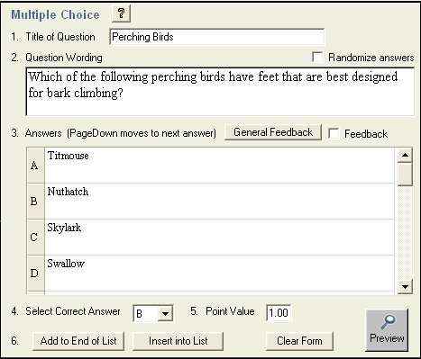

To create a new question, select the desired question type on the left side of the screen. The entry template on the right side of the screen will change accordingly.

Common Features Across all Question Types
All question types require you to enter a “Title.” The title can be up to 64 characters. If you do not enter a title, Respondus will use the first 20 characters from the “Question Wording” for it.

All question types have a “Question Wording” section. This is where the main body of the question is entered.

All question types allow the entry of “feedback.” If feedback is enabled for a particular exam, students will see the feedback for the answers they selected after they submit their answers. To enter feedback for a question (regardless of whether you later decide to use it with an exam), select the Feedback option on the edit form. The form will then display fields, directly below each answer choice, where feedback can be entered. “General Feedback” can also be entered by clicking the [General Feedback] button and entering the desired information. (Note: If you deselect the Enable Feedback checkbox on the side of the screen, all feedback remains stored with the question. It simply does not display the feedback on the Edit screen until the option is reselected.)

Four buttons appear at the bottom of all edit forms. The [Add to End of List] button adds the current question to the end of the “Question List” (located at the bottom of the screen). The [Insert Into List] button lets you insert the current question into the Question List at a specified location. The [Clear Form] button will erase all data that currently shows in the form. Finally, the [Preview] button opens a browser-like window that lets you view how the question will appear in the final exam--feedback and scoring information is also shown in this window. The Preview button can be selected at any stage in the editing process.

Question List and Expanded View
The “Question List” displays the title, question type, points, and question wording for each question in the file. The total number of questions and point values is shown at the top of the list. The first column enables you to preview an item by clicking the magnifying glass icon. The context menu in the next column will display a pop-up dialog with various operations that can be performed on that item.

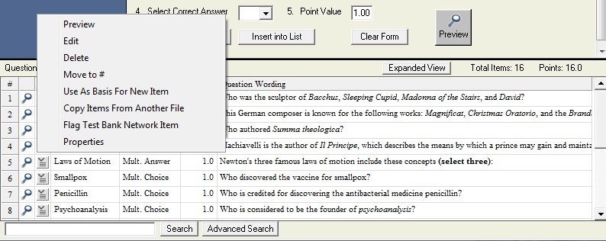

The context menu offers the following operations:

Preview – Preview the question.
Edit – Edit the question.
Delete – Delete the question.
Move to # - Move the question to a new location in the list.
Use As Basis For New Item – Open the question in the edit template and use it as the basis for a new item. The original title will be modified slightly – for example, the number “2” will be added to the end of the name.
Copy Items From Another File – Items can be selected and copied from another Respondus file into the current file.
Flag Test Bank Network Item – An item copied from the Test Bank Network can be flagged if problems are discovered with it. This operation will only appear in the context menu if the item originated from the Test Bank Network and has not been modified.
Properties – Displays a window that summarizes the properties for the item.

The “Expanded View” button, located at the top right of the Question List, displays a full screen pop-up of the question list. This enables you to view more items at once.

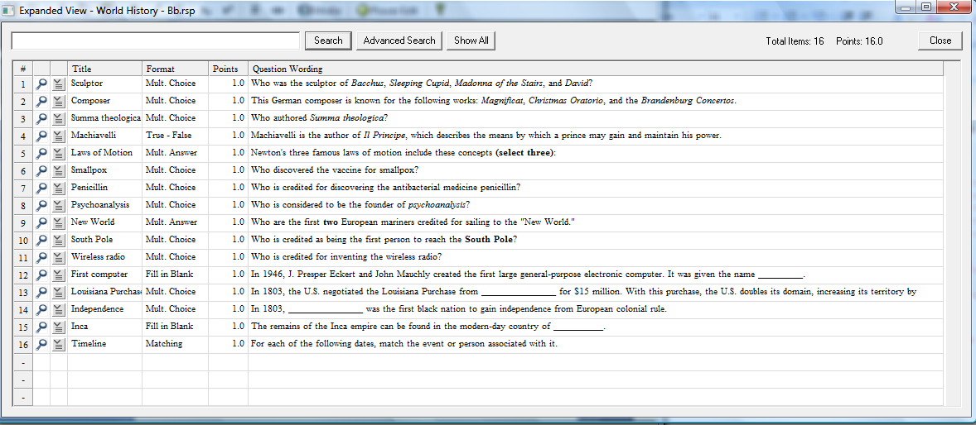

Multiple Choice
Multiple Choice questions can have up to 26 answer choices, but only one correct answer can (and must) be selected. You must also provide a point value for each question (the default setting is “1”).

Tip: The easiest way to navigate between the “Answer” fields in Multiple Choice questions is to use the PageUp and PageDown keys.

True or False
True and False questions are self-explanatory: enter the statement in the question wording field and then select either “True” or “False” as the correct answer.

Long Answer
Long Answer question types allow students to enter complete sentences or paragraphs for their answer. A correct answer can be entered for feedback purposes; however, most learning management systems still require the answer to be graded manually by the instructor.

Matching
Matching questions require students to match items from two columns. There are two ways to create matching questions in Respondus. First, the instructor may specify matching pairs for both the left and right columns--specifically, the correct match for the left column must be placed in the field immediately to the right. If this procedure is followed, it is not necessary to indicate the correct answer in the small column located at the far left.

The second approach for creating matching questions allows items in the right column to be placed in any order, but requires the correct answer for the match to be indicated in the small column located at the far left. This approach is especially suited for questions in which a long list of items (e.g., country names) is being matched to a relatively short list of items (e.g., type of government). For example, the left list might contain 20 countries (Afghanistan, Albania, Algeria, Angola, Argentina, etc.) while the list on the right might display four types of government (Multi-Party Democracy, One-Party Regime, Military/Monarchical/Theocratic Regime, Disordered State). Instead of entering the type of government for each country, you can simply enter the letter of the correct answer in front of the country name. See the table below.

Column1 Match Column
D Afghanistan A. Multi-Party Democracy
A Albania B. One-Party Regime
C Algeria C. Military/Monarchical/Theocratic Regime
D Angola D. Disordered State/Civil War
A Argentina
A Austria
A Bahamas
C Bahrain
A Bangladesh
B China
B Cuba

In a matching question, most learning management systems display the contents of the left column in the order the information was entered. The answers in the right column are generally scrambled. (Note it is possible to place extra answers in the right column. In this situation, the extra answers act as decoys and do not match any of the answers in the left column.)

Tip: The easiest way to navigate through the answer choices is to use the PageUp and PageDown keys.

All answer choices are equally weighted with matching questions. So if a question has 10 matches, each match is worth 10%.

Short Answer
Short Answer questions require students to enter a word, short phrase, or string of characters. Since the computer automatically grades the answer, students must give an answer that exactly matches one of the answers provided by the instructor.

Using the standard editing grid, Respondus allows the instructor to provide multiple variants of the correct answer. For instance, if the answer to a question is “New York Yankees,” the instructor might enter each of the following as an acceptable answer:

Yankees
New York
New York Yankees
NY Yankees

The user must use the exact spelling, spaces, and punctuation to receive credit (capitalization is ignored).

Multi-Select
The Multi-Select question type is very similar to Multiple Choice, except that students can (and generally should) select more than one correct answer.

Tip: The easiest way to navigate through the answer choices is to use the PageUp and PageDown keys.

In the column that precedes the answer choice, the letter “X” should be entered for all correct answers.

It is also necessary to select the type of “Credit Given” for correct and incorrect answers. Respondus offers two choices: “Right Less Wrong” and “All Points or None”. The “All Points or None” setting is straightforward: if any portion of the answer is wrong, no points will be awarded for the question. If the “Right Less Wrong” option is selected, incorrect choices are subtracted from correct choices. For example, if a student accurately selects the two answers out of four that are correct, but additionally selects a third answer that is wrong, she would receive 100% for answering the two questions correctly, minus 50% for the incorrect answer (for a total score of 50%). It should be noted that the default setting in Respondus prevents the final point value for a question from being negative (thereby preventing a student from losing points for answering the question incorrectly). This setting can be overwritten once questions are imported into Desire2Learn.

Ordering
Ordering questions allow students to provide an answer by selecting the correct order the answers are to appear. Enter the question wording or statement in the Question Wording field and then enter the answer choices in the correct order. Finally, enter a number indicating the order in which you want the answer choice displayed in the narrow column to the left of each answer.

Fill in the Blanks
The Fill in the Blanks question type presents students with questions that contain multiple blank spaces that must be filled in. For example:

People who live in _______ houses shouldn’t throw ________ .

For each blank that you want to appear in the question, you most enclose the correct answer in square brackets. For the above example, the question wording would appear as follows:

People who live in [glass] houses shouldn’t throw [stones].

The words in brackets will automatically be converted to answer blanks when presented to the student. This can also be previewed by clicking the “Preview” button. The wording can include up to 10 [words] to be filled in, each of which can have up to 20 correct answers.

Since the Desire2Learn server automatically grades the answers, students must provide answers that exactly match the answers provided by the instructor. The point value grading is always proportional to the number of correct answers.

Arithmetic
Arithmetic questions require students to apply a mathematical formula to answer the question. Arithmetic questions are designed using variables. Random values, based on a specified range, are automatically generated for each variable in the question. Thus, Arithmetic questions can be unique for each student, as illustrated in this example where values are inserted for {x} and {y}.

Example: If a car is traveling {x} miles per hour for {y} hours, how far does it travel (in miles)?

The Respondus editor for Arithmetic questions contains the following sections that need to be completed:

- Question Wording
- Formula
- Variable Properties
- Answer Properties
- Value/Answer Sets

Arithmetic – Question Wording
In the Question Wording section, enter the text of the question just as you would for any other question type. However, instead of using specific numerical values to define the details of the question, instead use variables by specifying a name enclosed in curly brackets for each one. For example: “How long does it take to travel {x} miles at a speed of {y} mph?”

Variable names can only contain letters and digits (the characters 0-9, a-z, and A-Z), and the “_” (underscore) character. In addition, the first character of a variable name cannot be a number.

You can use as many different variables as you need to define the question, and you can use the same variable name multiple times if necessary.

Note that adding images, complex HTML, etc. to the question wording will significantly increase the file size of the Flash object generated for the question, thereby limiting the number of different value/answer sets that will be available for random selection.

Arithmetic - Formula
In the Formula section, enter the mathematical formula associated with the question. This is the same formula that the student will be expected to use, and the same one that will be used to automatically calculate the correct answer for grading purposes. The same variables specified in the question wording will be used to indicate where each value should go in the formula.

The formula can be typed into the edit field directly, or entered by selecting options from the pull-down lists provided for Variables, Functions, Operators, and Constants. Selected options will appear in the edit field at the current cursor location, and will overwrite the current selection (if any).

The “Variables” list provides an easy way to select a common variable name.
The “Functions” list provides the following supported mathematical functions:

abs(x) Absolute value of x. abs(-3) = 3.
atan(x) Arc-tangent of x in radians
cos(x) Cosine of x in radians
cosec(x) Cosecant of x in radians
cotan(x) Cotangent of x in radians
exp(x) Base e (Euler’s constant) raised to the power of x
factorial(x) Factorial of x. fact(3) = 6.
ln(x) Base e natural logarithm of x
log(x) Same as ln(x)
sec(x) Secant of x in radians
sin(x) Sine of x in radians
sqr(x) Square root. sqrt(9) = 3.
tan(x) Tangent of x in radians

Note that the values for trigonometric functions are expressed in radians, not degrees. For conversion purposes, Pi radians = 180 degrees. Also, for all formulas that have two correct answers (for example, the square root of 9 is +3 and -3), only the positive number will be treated as correct.

After selecting a function from the list, the formula must be edited to replace the argument list with numbers or variables. For example, “round(d,x)” might be edited to specify a fixed number of decimal places and a variable to round, as in “round(3,{y})”, which would round the variable {y} to 3 decimal places.

Functions can also be nested within a formula, as in “sqrt(abs({x}))”. In this case, the absolute value of {x} is evaluated first, followed by the square root of the result. Functions can be nested as deeply as necessary to properly calculate the answer.

When entering numerical values, scientific notation is expressed in the format xEy, where x is the coefficient and y is the exponent. To convert numbers from scientific notation to standard notation, use x times 10 to the power of y. For example:

- 3.2E4 equals 32000
- -2E0 equals -2
- 3.14E-2 equals 0.0314

The “Operators” list provides the following standard mathematical operators:

- Subtraction
% Modulus or remainder. For example, 5%2 = 1.
() Parentheses used to group elements for precedence
* Multiplication
^ Power or exponent. For example, 2^3 = 8.
/ Division
+ Addition

The “Constants” list provides the following commonly-used numerical constants:

_e Base e or Euler’s constant (2.71828…)
_pi Pi – the circle ratio (3.14159…)

Some example questions and associated formulas might be:

Question: How long does it take to travel {x} miles at a speed of {y} mph?
Formula: {x}/{y}

Question: What is the positive square root of {x}?
Formula: sqrt({x})

Question: Compute sin(x) where x = {x} degrees.
Formula: sin({x}/180*_pi)

Arithmetic - Variable Properties
Clicking the “Variable Properties” button in the Formula section displays the Variable Properties dialog. Here, each variable in the question wording and formula is listed by name, along with Minimum, Maximum, and Precision values for that variable.

The Minimum and Maximum define the range of values each variable can be assigned, and the Precision specifies the number of decimal places each value should be allowed before the value is rounded off.

You can click each cell in the grid to edit the specific minimum, maximum, or precision value you want to change (the variable names cannot be edited). In general, for a given variable the minimum must be less than or equal to the maximum, and the precision must be greater than or equal to 0 and less than or equal to 5.

Arithmetic - Answer Properties
Clicking the “Answer Properties” button in the Formula section displays the Answer Properties dialog. Here you can specify values for answer precision and acceptable tolerance, as well as a unit name if required.

Answer precision can be specified in Decimal Places or Significant Figures. If the precision is specified in decimal places, the value must be greater than or equal to 0 and less than or equal to 5, just as with the precision values specified in the Variable Properties dialog. If the precision is specified in significant figures, the minimum value is 1.

Answer tolerance is the amount that the student’s answer can deviate from the calculated answer and still be considered correct. It can be specified as a fixed number of units or as a percentage of the answer value.

If you choose to require a unit name, comparisons with the name entered by the student will be case-insensitive and space-insensitive.

Arithmetic - Value/Answer Sets
Clicking the “Value/Answer Sets” button below the Formula section displays the Value/Answer Sets dialog. Here you can generate sets of variable values and calculate the associated answers using the formula previously entered. When the Arithmetic question is presented to the student, one of these value sets will be randomly chosen to populate the variables in the question wording and the formula, and the associated answer will be used to grade the student’s response.

The grid displays a list of numbered value/answer sets. The number of sets available can be selected from the “Number of Sets” pull-down list. The contents of this list will vary, depending upon the complexity of the question wording. For each set, the generated values for each variable are shown, and the individual cells can be clicked to edit those values. Note that any manually-entered values must be within the range specified by the variable minimum and maximum in the Variable Properties dialog. The answers cannot be edited; instead, the “Update Answers” button can be clicked to recalculate the answers for all value sets.

Adding Bold, Italic, Underline, and Super/Subscript
Respondus makes it easy to add enhanced formatting to question wordings, answers, and feedback. The bold, italic, and underline tasks work just like a standard word processor. Simply highlight the text you want to modify and click the appropriate [B], [I], or [U] button on the tool bar. The text will immediately change to the selected formatting. The superscript [X²] and subscript [X₂] tools function in the same manner. To remove any of the above-mentioned formatting, simply highlight the text again and reselect the corresponding button from the toolbar. (Please note that although the underlying “HTML tags” are not displayed in Respondus, these tags will be transferred to -- and displayed by – Desire2Learn when the file is uploaded.)

Media Wizard
One of the more powerful features in Respondus is the ease in which media (e.g., images, audio clips, video clips), attachments (e.g., spreadsheets) and links can be added to exams. Media content can be added to question wordings, answer choices, and feedback without writing or viewing HTML. In addition, the media objects can be previewed offline, and everything is automatically uploaded to the WebCT server during the Publish process.

From the Edit menu, position the cursor at the place in the question where you want the media item added. Then click the “Media” icon on the toolbar. A pop-up wizard will guide you through the selection of the media element.

The first step is to choose whether the media is being uploaded from a local computer or being linked to on the Internet. If the media file is located on your computer, the next step is to select the type of media being attached; image (.jpg, .bmp, .gif, .png, .pcx, .emf), audio/video file (.mpg, .avi, .wav, .mov, .swf) or other file type (.docx, .pdf, etc.).

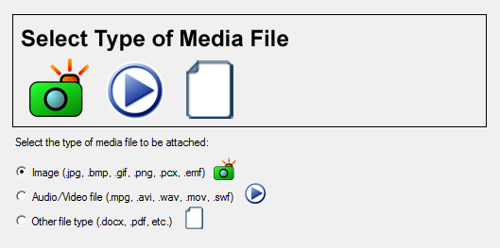

If images are selected, the Media Wizard will enable the entering of “alt text” (for screen reader applications) and will allow you to specify a scaling factor so that large images can be scaled to a smaller size.

When an Audio/Video file is attached to a question, the appropriate media player is automatically selected and you are given the option to insert it as an embedded object or a linked object.
If “Other file type” is selected, the file is displayed as a web link during the exam and the file can be viewed using a browser plugin or will launch another application that’s associated with that file type.

If external media is selected, the next step of the Media Wizard is to select an Image or Picture (Google Picasa Image or an image located at a URL) or Audio/Video file (YouTube video or an audio/video file located at a URL).

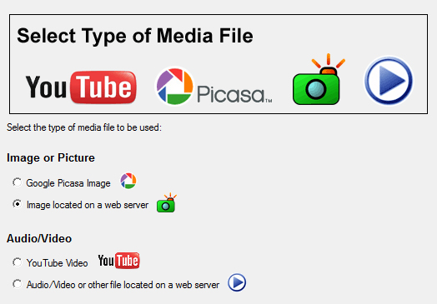

If Google Picasa images or YouTube videos are selected then the Media Wizard provides a search interface that allows you to search, preview, and select images and videos from the associated web sites for embedding or linking in the exam. Videos and images that are located on an external web server can also be manually linked to the exam.

Updating and deleting items added with the Media Wizard is as easy as clicking on the media icon that appears in the editor. When you select a previously added media element, a context menu will appear that allows you to update or delete the item.

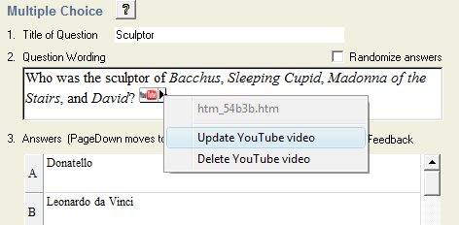

HTML Editor
Even instructors who are comfortable writing HTML often have difficulty sorting out the HTML they’ve written from the question wording itself. Respondus solves this problem by encapsulating blocks of HTML so that the question wording stays the focus of the screen. The only time an instructor has to view HTML is while the Respondus HTML Editor is being used.

From the Edit menu in Respondus, position the cursor at the location in the question where you want to begin a block of HTML. Then click the “HTML Editor” icon on the toolbar (represented by the symbol <H>) to open the editor. Enter the desired HTML by typing or pasting it into the editor--it is also possible to retrieve the HTML from a file located elsewhere on your hard drive by using the “Read File” option. Click [OK] to close the HTML Editor. A set of characters representing the HTML block will appear at the insertion point: <H_1> for the first block, <H_2> for the second block, and so on. To see how the HTML will appear in Desire2Learn, click the preview button.

To delete an HTML block, position the cursor in the same field where the HTML block is located, and select the “HTML Editor” icon from the toolbar. Choose the option to delete the HTML block and highlight the block you want to delete. Click [OK] to close the HTML Editor.

Equation Editor
The process of adding equations is similar to how media objects are added (see the earlier discussion). Equations can be added to question wordings, answer choices, and feedback, all without writing HTML.

From the Edit menu, position the cursor at the place in the question where you want the equation located. Then click the “Equation Editor” button on the toolbar, which is represented by a summation symbol. The Equation Editor will open and you can begin creating the equation. The Equation Editor in Respondus works almost identically to the one that is available with Microsoft Word and WordPerfect. So if you’ve used those equation editors before, you’ll already know how to use this one. The key thing to learn about the Equation Editor is that the top row of menu options consist of “symbols” while the bottom row of menu options consist of “palettes”. If you select a “symbol” from the top row, it’s no different than if you selected the + or = sign on your keyboard -- except that the symbols from the Equation Editor eventually get displayed as graphics since most symbols can not be viewed with a standard web browser. When you select a “palette” from the bottom row, you are given the opportunity to enter text at various insertion points shown on the screen. You can also select a palette from the bottom row, click in an insertion point, and then select a symbol from the top row. For more information about the Equation Editor, refer to the online help that is available from within the editor.

Once you finish editing the equation, exit the Equation Editor by either clicking the [X] that appears at the top right corner of the window or by selecting File from the pull-down menu and clicking Exit (do not simply minimize the Equation Editor). A second window that addresses the size of the equation will now appear. The font selection and size used within the Equation Editor determines how large the equation will be when it is printed from Respondus. But it is generally desirable to show equations in a larger format when displaying them on the web. In general, we recommend that a web-based equation be displayed at 150% of the size used for printing. So by default, the Respondus software suggests that the “Web Browser Image Scaling” for the equation be increased to 150%. To accept this setting, simply click the [OK] button. If you want the graphic to appear even larger in the Desire2Learn quiz, then you can increase the scale to up to 1000%. It’s important to note that changing the image scale using this option only affects how it will appear in a Desire2Learn quiz -- you are not affecting the size of the equation that will print from Respondus. In order to change the size of the equation for printing purposes, you must select a different font size in the equation editor itself.

An additional “Alt” field allows a text description to be added to the equation image so it can be utilized by an ADA-compliant screen reading browser. This text is also displayed when the mouse pointer is held over the image. If you simply click [OK] to close the window, the generic text “equation” will be used for the “alt” field. If an expanded textual description is entered (such as “b is greater than or equal to c”), it will be used by the screen reader instead.

Once an equation has been added and you return to the Edit menu, a short string of characters representing the equation object will appear in green text. An equation placed in the question wording will look something like <EQ_1>, with the next equation being displayed as <EQ_2>, and so on. When an equation is placed in an answer choice or feedback, it will appear as a small red box, except when that field is being edited.

To modify or delete an equation, position the cursor in the same field where the equation is located. Then click the Equation Editor icon on the toolbar and select the option to modify or delete an existing equation.

To preview questions containing equations, select the [Preview] button. We recommend that you preview all questions containing equations before saving the file to Desire2Learn format.

Using MathType with Respondus
The Equation Editor in Respondus is a special version of MathTypeTM by Design Science. If you frequently create documents with equations, you may find MathType is better suited to your needs. MathType is as easy to use as the Equation Editor and has many extra features to help you save time and create a wider range of equations.

MathType is available in English, Japanese, German and French. For further information about purchasing MathType, contact your software dealer or Design Science directly: Design Science, Inc., 4028 Broadway, Long Beach, CA 90803, USA.

Toll free: 800-827-0685 International: 562-433-0685
Fax: 562-433-6969
Email: sales@dessci.com
World Wide Web: http://www.dessci.com

If you already own MathType, you will need to reinstall it in order to have it work directly with Respondus. MathType's readme file explains that it sets itself up to replace Equation Editor at the time that it's installed. So if you add a new application like Respondus that uses the Equation Editor, you must re-install MathType.

Power Edit
The “Power Edit” task available from the Edit menu provides additional features for formatting questions, including a table editor, bulleted lists, the ability to change fonts and justification, and so forth. In addition, the Power Edit window provides a much larger workspace, which is especially useful if you are creating tables or editing questions that have large blocks of text.

To begin, click in the field that you want to edit and then click the “Power Edit” button on the toolbar. Several of the tasks on the Power Edit toolbar also appear on the main toolbar, so only the unique features will be discussed below.

Tables
Respondus makes it easy to insert and edit tables. From the Edit menu in Respondus, position the cursor at the location where you want to insert the table. Then click the “Power Edit” button and select the “Insert Table” icon from the toolbar (located at the top right). When the next pop-up window appears, specify the number of columns and rows that should be included in the table (all other settings are optional). Click the [OK] button to return to the Power Edit window. You can now click within the cells of the table and enter the text.

The width of the table cells can be adjusted by dragging the column lines. To edit other aspects of the table from the Power Edit menu, click within the table and select the desired action from the pull-down menu labeled “Table.” Use the “Insert” option to add a row or column to the table. Use the “Delete” option to delete a row or column, or to delete the entire table. Other formatting (such as font changes and the centering of text) can also be applied to the cells in a table.

Finally, keep in mind that it is usually possible to paste tables into Respondus directly from Microsoft Word. Also, Respondus tables are designed to support both web-based exams and print exams. So you only have to create a table once if you require both online and print exams.

Fonts, Formatting, and Lists
The other features in the Power Edit task are self-evident if you are familiar with the basic functioning of a word processor. To apply a different font to text, simply highlight the text and select the desired font and size from the pull-down lists. Text can be left justified (the default), right justified, and centered by selecting the appropriate toolbar button. Finally, create bulleted or numbered lists by selecting the corresponding option from the Power Edit toolbar.

To see how the formatting will appear in Desire2Learn, click the preview button that is located at the top left of the Power Edit toolbar. To exit the Power Edit window, simply click the [X] at the top right corner of the window, or go to File and click Save & Exit.

Spell Check
The Spell Check feature, located on the toolbar when the Edit menu is selected, will search the currently open file for spelling errors and allow corrections to be made. Once the Spell Check feature is started, it will search for words that do not match items contained in the dictionary. If the word is not found in the dictionary, you are given the option to “Change” the word to one that is suggested, to “Ignore” the identified word, to “Change All” such words in the file to one you select, or to “Add” the word to the dictionary. If you want to make more detailed changes to the question, click the “Edit This Question” button, which will close the spell checker and make the question available for editing.

Three dictionaries are included with a standard installation of Respondus: American English, Canadian English, and British English. However, a free bundle of supplemental dictionaries can be downloaded from the Respondus website, including French, German, Spanish, Dutch, Finnish, and a comprehensive medical dictionary.

Keyword Searches
There are several places in Respondus where the [Search] and [Advanced Search] buttons appears, such as at the bottom of the Edit and Expanded View menus. A quick search can be performed by entering a search term in the field next to the [Search] button. The [Advanced Search] option also allows you to search the currently open file, or the file that is being previewed.

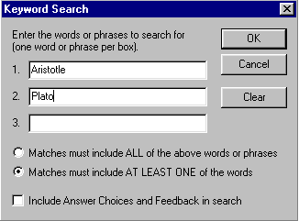
Up to three words can be included in an Advanced Search. When more than one word is used, you can choose whether a match is required of all words or any of the words. A final option allows you to include answer choices and feedback in the keyword search.

Settings Menu
Overview
Properties
Restrictions
Attempts / Submissions
Layout
Random Sections
How to Save New Default Settings

Overview
Respondus allows the selection of settings for a quiz or survey prior to it being uploading to Desire2Learn. Although this step is entirely optional, it provides the ability to set various properties such as the notification email, availability, and the number of attempts (among many others).

Properties
The section labeled Properties includes general settings for most quizzes.

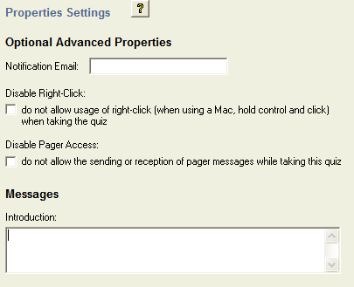

Notification Email:
The email address specified in this field will receive an email message anytime that a student completes a quiz attempt.

Disable Right Click
Disabling right-click (when using a Mac, hold control and click) applies when a user is taking a quiz and exists to deter users from printing the quiz’s questions.

Disable Pager Access
Disabling pager access restricts sending or reception of pager messages while taking a quiz.

Introduction
The introduction is shown at quiz commencement.

Restrictions
The section labeled Restrictions includes availability, quiz password, IP address and various timing restrictions.

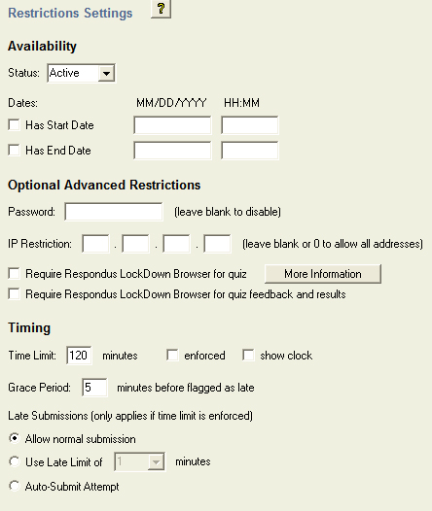

Status
The quiz status can either be Active or Inactive. When a quiz is Active student may start the quiz and when Inactive the quiz is not available to students.

Dates
Start and end dates and times may be specified for when the quiz is available for students.

Password
Only users who enter this password will be granted access to the quiz.

IP Restriction
Only users coming from the specified IP address will be granted access to the quiz.

Respondus LockDown Browser
If your institution uses Respondus LockDown Browser, it is possible to enable the quiz settings for the browser by selecting one or both of the Respondus LockDown Browser options.

Time Limit
When enforced, students will only have the available time (in minutes) to complete the quiz. Optionally, a count down clock may be shown.

Late Submissions
When “Allow normal submission” is selected, users can submit their quiz regardless of the time limits. If the quiz is submitted after the time limit no points are deducted.

When “Use Late Limit of” is selected users can submit their quiz, regardless of the set time limit. If the quiz is submitted after the Time Limit + Late Limit time expires, the student will receive a score of 0 on the quiz. The score can still be manually graded if it is felt that the student deserves more than 0. Please note that the Late Limit restriction only applies if the “enforced” box is selected.

When “Auto-Submit Attempt” is selected the system can only automatically submit an attempt when the user performs an action after the time period has expired. If the user takes no action, the quiz will show the attempt as ‘attempt in progress’ in the quiz grading area. Please note that the Auto-Submit Attempt restriction only applies if the “enforced” box is selected.

Attempts / Submissions
The section labeled Attempts / Submissions includes the number of attempts allowed, the message users receive after they submit their assessment, and settings for other types of feedback.

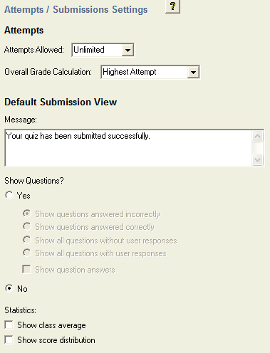

Attempts Allowed
If more than one attempt at a quiz is permitted, users will be able to continue to take the quiz until all allowed attempts are used.

Overall Grade Calculation
For quizzes with multiple attempts, an overall grade is determined based on the Overall Grade Calculation method.

Message
This message will be presented to users after they successfully submit their quiz.

Show Questions?
Show Question views are a way of giving feedback to users after they finish their quiz. Feedback can be restricted to questions that are answered incorrectly, correctly, questions without user responses, and questions with user responses.

Selecting ‘Show question answers’ will display the answers next to each question that appears. Answers will not appear for questions that are not displayed.

Statistics
The class average and the score distribution may be displayed to the user upon completion of the quiz. At any given time, only the most recent statistics will be displayed to users.

Layout
The section labeled Layout includes settings that control how the quiz is displayed and how users can navigate through the quiz.

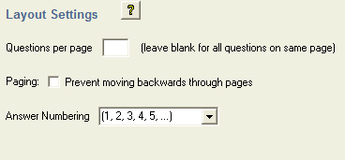

Questions per page
When used, this parameter will control how many questions are placed on a page for presentation purposes; otherwise the entire quiz will appear on the same page.

Paging
When this option is enabled, users taking the quiz will only be able to move forward through pages. They will not be allowed to move to a previous page once they have left it.

Answer Numbering
The Answer Numbering option allows quiz answers to be numbered numerically, with lowercase roman numerals, upper case roman numerals, lowercase alphabetic, uppercase alphabetic or simply set to no enumeration.

Random Sections
Desire2Learn supports the creation of "Random Sections," which are sets of questions that are randomly selected during a quiz. Before creating a random section in Respondus, it is important that questions intended for these sets be organized and grouped properly. For example, if the fifth question in the quiz is going to be randomly selected from a set of three questions, then those three questions should be grouped together at 5, 6, and 7 in the file. Make sure your questions are organized in this manner before continuing.
To create a random section, go to the Settings menu and select the "Random Sections" tab. Click the Random Sections button to continue.
Then select the option "Add New Set" and enter the first and last numbers -- that is, the range -- of the questions that will comprise the set. For instance, if you want questions 5, 6, and 7 to be the basis of a question set, you would enter 5 as the first question and 7 as the last question in the set.
If you want all of the questions in the set to be shown randomly during the quiz, select the "All" option. If, however, you want a smaller number of questions from the set presented during the quiz, choose the "Select Number" option and provide the desired number. For example, if you want only one question from questions 5-7 asked during the quiz, you would enter the number 1. You are then asked to provide a point value for the set. (All questions in a set must have the same point value.)
Finally, click the "Add New Set" button to finish the creation of the set. In the list below, a letter representing the question set will appear next to each question that is contained in the set. This allows you to easily see which questions are grouped together.
The letters representing each set also provide the basis for editing a question set. For instance, if the letter "C" appears next to a set of questions, and you want to edit this particular question set, select the option "Modify or Delete Existing Set" and select "C" from the pull-down list. The current settings for that question set will be displayed and several new options will appear in the lower section of the screen: Save Changes, Cancel Changes, and Delete Set.
In order for random section settings to be included with the quiz when it is published to Desire2Learn, you must select the checkbox "Apply Random Sections" on the Publish to Desire2Learn wizard. Conversely, if you do not want random section settings uploaded with the quiz when it is published to Desire2Learn, leave this box unchecked.

How to Save New Default Settings
In Respondus there are two types of default settings: the original settings as displayed in Desire2Learn, and a second set of default settings that you can determine yourself. To save your own default settings, select the options you want across the setting tabs. Then click the [Use as New Defaults] button on the left side of the screen. From this point forward, all new files created in Respondus will have the new default settings attached to them.

If you modify the settings and later wish to restore the default settings (either your own default settings or Desire2Learn’s), simply click the [Restore Default Settings] button. You will be asked which settings you want to restore.

Preview & Publish
Overview
Preview
Publish
Print Options

Overview
Once a quiz is created in Respondus, the Preview and Publish menu let’s you determine what to do with the file. Most users will first want to examine the contents of the file using the Preview task. When the questions are ready to be uploaded, the Publish to Desire2Learn task connects Respondus to the Desire2Learn server and transfers the exam to it. Finally, the Print task lets you format and print the exam directly from Respondus, or you can bring a file into a word processor for further enhancement and printing.

Preview
The Preview task, located on the Preview & Publish menu, is similar to the preview option that appears in the Edit menu. The primary difference is that here you can easily scroll from one question to the next.

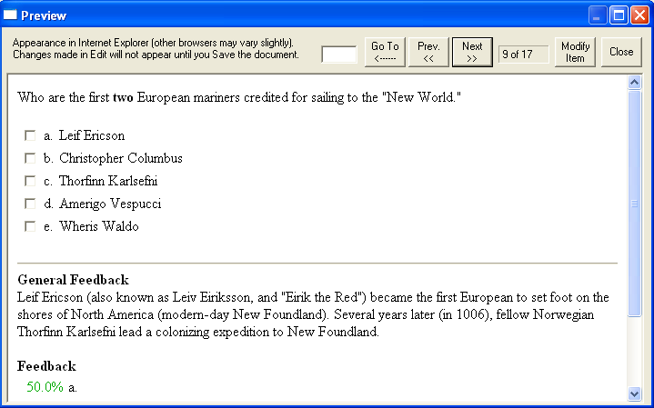

The preview window shows how the question wording and answer choices will appear to students when they take the exam. The feedback and correct answer for the question is additionally displayed at the bottom of the window.

To edit the question being displayed in the Preview window, click the [Modify Item] button. The screen will change to the Edit menu and the question will be displayed in the editor. Make the required changes and click [Save Changes].

Publish
The Publish to Desire2Learn wizard is available from the Preview & Publish menu and it guides a user through the steps of publishing a quiz to the Desire2Learn server. You must already have a Desire2Learn account and password in order to use this task. In addition, it is helpful to understand the basic approach used by Desire2Learn to create an online quiz.

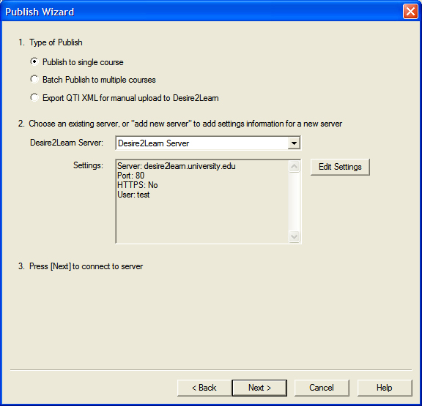

The initial decision is to choose whether the quiz is being published to a single course, multiple Desire2Learn courses (Batch Publish), or will be exported as a QTI XML file for manual uploading to Desire2Learn. Note: The “Batch Publish” feature is only available in the Campus-wide version of Respondus.

The second step requires that information be entered about the Desire2Learn server and the user account. (This information can be stored for future use, enabling this step to be bypassed after the initial setup.) From the Desire2Learn Server list, select “Add New Server.” A window will open.

The Campus-wide version of Respondus will offer to check whether “Preconfigured Server Settings” are available for your institution. Select “Yes...” to perform this check, which may enable you to skip the instructions in the next paragraph.

If Preconfigured Server Settings aren’t available, or if you’re using the single-user version of Respondus, follow the instructions shown.

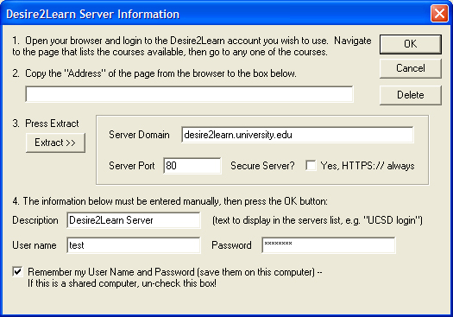

First, as instructed on the screen, open a web browser and login to your Desire2Learn course. Select a course and then copy the complete URL for this page and paste it in the field provided. (The easiest way to copy a URL displayed by a browser is to highlight it with a mouse, click the right mouse button, and select "copy". Then go to the appropriate field in Respondus, click the right button again and select "paste".) Upon clicking the "Extract" button, Respondus will fill in the Server Domain and port fields.

Now provide a short description for the Desire2Learn server. The server can be called anything you like, such as "My Desire2Learn courses."

Enter an instructor-level User Name and Password. This information should be the same as what is entered when using a web browser to access the Desire2Learn course. If you want Respondus to remember the User Name and Password for future sessions, select the "Remember my User Name..." setting. Click [OK] to close the Server Information window.

Before clicking [Next], be sure you are connected to the Internet. If using a dial-up connection, go ahead and connect to the Internet now.

Click [Next] to continue. If the connection is successful, the next page of the wizard will appear. If the connection is unsuccessful, an error message will indicate that Respondus was unable to connect to the server using the provided settings. If this occurs, troubleshoot it as follows:
- Make sure your connection to the Internet is working properly.
- Double-check the instructor-level Password and User ID information. In fact, open a browser, go to the Desire2Learn server, and enter the identical login information. This will confirm that the Desire2Learn server is running and that the User ID and Password are correct.
- Make sure you are running the latest version of Respondus (go to Help>Check for Update to see if a more current version is available).
On the next page of the wizard, you are prompted to select a course from the pull-down list.

Now decide whether to create or replace a quiz, self assessment or question library section that already exists in the Desire2Learn course. To create a new quiz, select that option and enter a name for the quiz. To replace an existing quiz (self assessment or question library section), click the "replace existing quiz" option and select the quiz from the pull-down list. (Note that a quiz can only be replaced if it has not yet been administered to students.)

Additional options can be selected at this point. Settings can be applied as can random sections.

Click [Next] and Respondus will begin publishing the quiz and settings to the Desire2Learn course. A status report appears during the publishing process. For a typical quiz, the publishing process takes 20-40 seconds. This can increase to several minutes or more if a large number of media files are being uploaded or if the server connection is particularly slow. You will know that the publish process is complete when the phrase "Completed successfully" appears in the "status" window.

After a quiz is published to Desire2Learn, it is recommended that you go to the course and confirm that everything appears as expected.

Exporting a Quiz for Manual Upload to Desire2Learn
To save a currently opened file to the Desire2Learn export format, select the “Export QTI XML” option from the first step of the Publish Wizard.

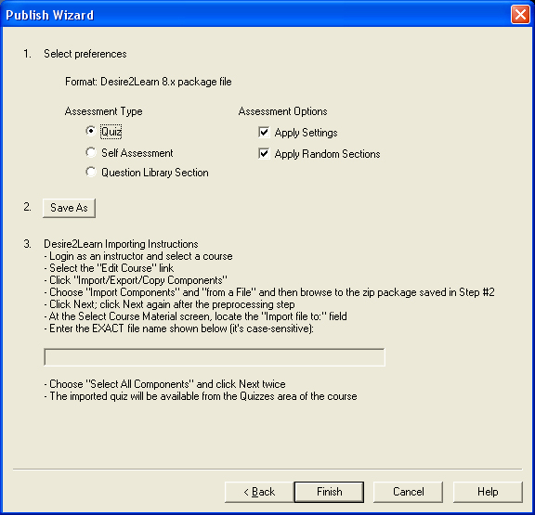

Step 1
Select the Assessment Type and Assessment Options for your Desire2Learn package file. Valid assessment types include Quiz, Self Assessment, and Question Library Section. Valid assessment options include Apply Settings and Apply Random Sections.

Step 2
Next click the [Save As] button and browse to a location for saving the Desire2Learn Export file. Upon clicking [Save] the file will be saved to that location.

Step 3
When importing the file into Desire2Learn the following steps must be followed:

- Login as an instructor and select a course
- Select the "Edit Course” link
- Click “Import/Export/Copy Components”
- Choose "Import Components" and “from a File” and then browse to the zip package saved in Step #2
- Click Next; click Next again after the preprocessing step
- At the Select Course Material screen, locate the “Import file to:” field

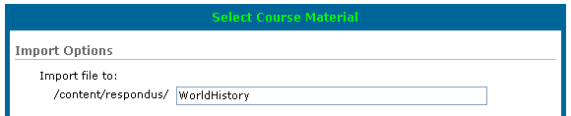

- Enter the EXACT file name shown in Respondus (it’s case-sensitive):

- Choose “Select All Components” and click Next twice
- The imported quiz will be available from the Quizzes area of the course with the same name selected above

Printing Options
Respondus allows you to format and print exams/surveys directly from the software. It is also possible to save an exam to MS Word format for further enhancement and printing. To begin, go to the Preview and Publish menu in Respondus and select the Print Options tab.

The screen now displays the printing options available in Respondus. There are three formatting templates from which to select: Exam, Exam with Answer Key, Answer Key Only. Once a template is selected, you can further modify it by clicking the Settings button to its right. If the exam being printed has matching questions, be sure to select the checkbox labeled "Matching, randomize answers" if you want the second set of answers to be randomized. Also, if you have sequential questions that refer to the same image or graphic, you will likely want to select the “Suppress Repeated Images” button so that the image is not repeated with each question.

Click the [Edit Headers] button to enter the information you want to appear at the top of each page. Different information can be entered for the second and subsequent pages too. The header information might look something as follows:

The next section allows up to 10 variations of the exam to be generated. You have the ability to “randomize all” questions in the exam or to have the questions randomized according to question type (i.e., all the multiple choice questions are randomized within a group, all the essay questions are randomized within a second group, and so forth). If you don’t want multiple exam variations, simply retain the “Original Order” option from the pull-down list. (Note: As long as the questions in the exam file remain unchanged, a particular “Exam Variation” will have the same question order each time it is printed or saved to MS Word format. However, if you add or insert new questions, the Exam Variation will differ the next time you print/save an exam or answer key.)

It is also possible to specify a range of questions to be included in the exam. If both fields are left blank, all questions will be included.

At the bottom of the screen there are three options: Text Preview, Save to File, and Send to Printer. The Text Preview button allows you to preview the contents of the file in a pop-up window. We recommend that you use this option before printing the exam or saving the contents to a file--it is a quick way to identify mistakes. The Save to File option allows the creation of a MS Word file (.doc), a “rich text file” (.rtf), or a standard text file (.txt). The MS Word and .rtf formats will retain enhanced formatting such as bold, italics, and underlining, whereas the .txt format will strip such information. Once a file is saved, it can be opened with a word processor for further formatting and modification. Finally, the Send to Printer option permits you to print directly from Respondus. This task works similar to the printing function in other Windows programs.

Retrieval
Overview
Retrieving a Quiz from Desire2Learn

Overview
Respondus allows the retrieval of the exam instrument from Desire2Learn so that it can be modified in Respondus, published to another course, or archived.

Retrieving a Quiz from Desire2Learn
Respondus allows the retrieval of quizzes from a Desire2Learn course. To begin, go to the Retrieval menu in Respondus. The next few steps for retrieving a quiz are identical to those used for publishing quizzes to Desire2Learn (see the related discussion for a detailed explanation). First, select the Desire2Learn server and course. Next, choose the specific quiz, survey, self assessment or question library section you want to retrieve and enter a name for the new Respondus file you are creating.

Once all selections have been made, click the [Next] button. The retrieval process will take between 15 seconds and several minutes, depending on several factors: the speed of your connection, the load on the server, the size of the media elements that are being retrieved, and so forth. You will know that the retrieval is successful by the statement “Completed successfully” that appears in the status box.

When a file is being retrieved, Respondus will detect if media objects are associated with it and will automatically download these objects if they are stored with your Desire2Learn course. (Respondus does NOT attempt to download media elements if they are stored on a different server.)

If you created and uploaded math symbols or equations to Desire2Learn using Respondus, when these symbols are retrieved from Desire2Learn they will be treated from that point forwarded as images, not equations. This means that if you want to use Respondus to modify an equation that was retrieved from Desire2Learn, you will first need to delete the equation graphic using the “Insert Picture or File” option (see above discussion) and then use the Equation Editor to create the new equation. Hence, it is usually better to edit your original Respondus file since it permits you to edit the equation directly. (Note: if the equation was created in Desire2Learn itself, it will be downloaded to Respondus as an HTML block and will not be editable using the Respondus equation editor.)
Other Tools & Features
Overview
Save As Copy
Save As StudyMate Class Format
Preferences
Update License
Cleanup HTML Tool
Question Title Tool
Check for Update

Overview
There are several additional tools in Respondus that offer a range of functions. Each is discussed below.

Save As Copy
The “Save As Copy” tool is located on the File pull-down menu. Use this task to create a copy of the currently open file.

Save As StudyMate Class Format
The Save As… tool, located on the File pull-down menu, can also be used to save Multiple Choice and True/False questions to the StudyMate Class zip format (.zip). Once saved, the file can be imported into a StudyMate Class instance or by StudyMate Author, a separate product by Respondus Inc.

Question types other than Multiple Choice and True/False are dropped during the export to the StudyMate Class zip format.

Exported items that contain images are handled as follows. If an item contains a single image, that image is placed at either the beginning or end of the question once it’s imported by StudyMate Class (the beginning/end positioning is based on its proximity to the beginning or end in the original question wording). If an item has multiple images, only the first image is retained, with the text “*IMAGE*” inserted where additional images appeared in the original item.

The StudyMate Class format can also be imported into StudyMate Author, with True/False questions being converted to Multiple Choice questions with only two answers.

Preferences
A “preferences” option is located on the File menu bar, contains five tabs: General, Edit & Publish, Retrieval, Conversions and Auto-Save.

The top section of the General preferences allows you to prevent Respondus from automatically checking for updates to the Respondus software. (The checking occurs whenever an exam is published from Respondus to an online course.) Directly beneath this is a list of learning management systems. If you only want to be informed of updates that relate to specific learning management systems, unselect those systems for which you are not interested. The final option on the General tab allows the current description of the Respondus file to be edited.

The Edit and Publish preferences provide a variety of options:

- The ability to discard font changes when copying and pasting from another program
- The ability to change the default point value for new questions that are created or imported
- The ability to prevent the “ALT text” window (for entering text for screen readers) from appearing each time an image is added to an exam
- The scaling percentage that should be used for equations that are published to the online course
- The ability to change the default font for questions that are published to Blackboard. (We highly recommend that you don’t change the default font. If you change the default font and later need to edit your questions from within Blackboard using a browser, it will be more difficult because the font HTML will be intermixed with the question wording. Also note that changes to the default font will not be applied to tables or any text that already has a specific font applied it.)

The fourth preference tab, Conversions, allows the settings to be determined for files that are converted from one LMS personality to another. If you do not want to be asked each time how certain issues should be handled for the file conversion, then select the settings that you prefer.

The Auto-Save tab controls what actions, such as adding a new question or editing an existing question, cause the program to automatically save the current document.

Update License
For the campus-wide version of Respondus this allows updating the license information at any time, for example to change the support contact or to renew the license early. Update License is located under File on the menu bar.

Cleanup HTML Tool
Questions imported from a Word document or by pasting from Word into a question editor may contain more formatting than is needed, such as font changes and styles that don’t work properly with a learning management system server.

The Cleanup HTML tool, located under File on the menu bar, allows you to apply three levels of cleanup to all questions in the current file. The first level strips away some extra font and style information that is usually not appropriate for use on servers. The next level removes almost all font information so that the server’s normal fonts are used instead of other fonts. The final level removes almost all formatting which can solve problems with unsafe HTML that are not fixed using the other two levels.

Question Title Tool
There are many situations when it is desirable to rename all the titles in the Respondus file to provide a consistent look or numbering sequence. For example, if questions are copied or imported from a variety of sources the resulting titles may look inconsistent and haphazard.

The Question Title Tool, located under File on the menu bar, lets a “stem” (or prefix) be specified for question titles. Consecutive numbering will automatically be generated for the text that appears after the stem, beginning with 1 (or 01, or 001, etc.). For example, if you enter “Chapter1-” as the stem text, and then select “001” as the format for the numbering scheme, the title for the first question will be changed to Chapter1-001, the title for the second question will be changed to Chapter1-002, and so on. If a range is specified for the titles being changed, even more specific titles can be provided throughout the file. For instance, questions 1-20 might use the stem “Ch1-Unit1-” and questions 21-30 might use the stem “Ch1-Unit2-” and so forth.

Check for Update
The “Check for Update” tool, located on the Help menu bar, provides an easy way to see if an update is available for Respondus. When Respondus is used to publish an online exam (publishing is only available with certain LMS personalities), it will automatically check to see if an update is available for the Respondus software. This auto-check will occur only once in a 24-hour period. No information about your computer hardware and software is collected by Respondus, Inc. during this process. Instead, the Respondus software retrieves information from Respondus.com and will display a message if an update is available. You will then have the choice of upgrading to the latest version of the software.

To manually check for a software update, select the “Check for Update” option from the Help pull-down menu (you will need a live Internet connection). Respondus will instantly return a message indicating whether an upgrade is available. If an upgrade to Respondus is available, you can let Respondus download the required file(s) automatically and update the software for you. This is the easiest way to apply a patch or upgrade.

If you prefer that Respondus does not automatically check for an update during the publishing step, go to the File menu, select Preferences, and unselect the appropriate checkbox under the General tab.
Disclaimer of Warranty
While Respondus Inc. has tried to ensure the dependability of the software and documentation, it is provided "as is" without warranty of any kind. Agents of the supplier may have made statements about this software. Any such statements do not constitute warranties and shall not be relied on by individuals in deciding to use the program.

Because of the diversity of conditions and hardware under which this program may be used, no warranty of fitness for a particular purpose is offered. Test the program thoroughly before relying on it. You assume the entire risk of using the program. Respondus, Inc. shall not be liable for any expense, claim, liability, loss, or damage (including any incidental or consequential damage), loss of profits, loss of reputation, or any loss whatever direct or indirect, by you from either the use of or the inability to use the software.

Copyright, Ownership, and Use of Software
All software, with exception of Equation Editor by Design Science and the Sentry Spelling-Checker Engine by Wintertree Software, remains the property of Respondus, Inc. The software and written materials are copyrighted. This license is not a sale of the original software or any copy. You own the physical media on which the software is originally or subsequently encoded, but Respondus Inc. retains title and ownership of the software on all media.

You are not permitted to install the executable code version of this product on a network server or virtual server. You may not customize the Respondus “Product.” Except as otherwise permitted by written consent, you may not: (i) modify or create any derivative works of the Product or documentation, including translation or localization; (ii) decompile, disassemble, reverse engineer, or otherwise attempt to derive the source code for the Product; (iii) redistribute, encumber, sell, rent, lease, sublicense, or otherwise transfer rights to the Product; or, (iv) remove or alter any trademark, logo, copyright or other proprietary notices, legends, symbols or labels in the Product.

© 2000-2011 by Respondus, Inc. All Rights reserved. The Equation Editor and documentation are copyrighted by Design Science, Inc. The Sentry Spelling-Checker Engine is copyrighted by Wintertree Software, Inc.

Respondus is a registered trademark and Respondus LockDown Browser is a trademark
of Respondus, Inc. All other trademarks are the property of their respective owners.
Copyright © 2011 Respondus

